*Software Design and Paradigms*

*(CS3036)*

*Lab Assignments*

*Third Year – Semester II, Module VI*

*Division D - Bachelor of Technology – Computer Engineering*

**Bract’s Vishwakarma Institute Technology**

**PUNE – 411037**



*1 February 2020*

*Prepared by:*

|  |  |  |  |
| --- | --- | --- | --- |
| **Name** | **Division** | **Roll Number** | **GR Number** |
| Riya Mate | T.Y. D | 8 | 1710954 |
| Neha Khare | T.Y. D | 18 | 1710176 |
| Aditi Patil | T.Y. D | 28 | 1710383 |
| Akshay Patil | T.Y. D | 29 | 1710456 |

***Approved by:***

|  |  |  |
| --- | --- | --- |
| ***Name*** | ***Signature*** | ***Date*** |
| ***Prof. Mahesh Dube*** |  | ***03 Feb 2020*** |

|  |  |  |
| --- | --- | --- |
| **Assignment No.** | **Assignment Name** | **Page No.** |
| **1.** | **Requirement Definition Document (RDD)** | **3** |
| **2.** | **System Requirement Specification (SRS)** | **8** |
| **3.** | **Business Process Diagram (BPD)** | **23** |
| **4.** | **Use Case Diagram** | **29** |
| **5.** | **Sequence Diagram** | **80** |
| **6.** | **State Chart Diagram** | **100** |
| **7.** | **Activity Diagram** | **114** |
| **8.** | **Class Diagram** | **128** |
| **9.** | **Component Diagram** | **143** |
| **10.** | **Deployment Diagram** | **159** |
| **11.** | **Design Pattern** | **169** |
| **12.** | **Screenshots** | **174** |

***Requirement Definition Document***

***Assignment 1– SDP LAB (CS3036)***

***Personal Counselling System***

Department of Computer Engineering

**BRACT’S Vishwakarma Institute Technology**

***PUNE – 411 037***



*Prepared by:*

|  |  |  |  |
| --- | --- | --- | --- |
| **Name** | **Division** | **Roll Number** | **GR Number** |
| Riya Mate | T.Y. D | 8 | 1710954 |
| Neha Khare | T.Y. D | 18 | 1710176 |
| Aditi Patil | T.Y. D | 28 | 1710383 |
| Akshay Patil | T.Y. D | 29 | 1710456 |

*Approved by:*

|  |  |  |
| --- | --- | --- |
| ***Name*** | ***Signature*** | ***Date*** |
| *Prof. Mahesh Dube* |  | *30th Mar 2020* |

**TABLE OF CONTENTS**

|  |  |
| --- | --- |
| **TITLE** | **PAGE** |
| 1. **Context** | 5 |
| 1. **Problem** | 5 |
| 1. **Solution** | 6 |
| 1. **Benefits** | 7 |
| 1. **Concept Diagram** | 8 |

|  |
| --- |
| 1. ***Context*** |

To ensure the quality teaching-learning process in Institutions, right from the entry of the student through competition, streamlining of admissions is one of the important parameters.With this view and to resolve the generic problems faced by the candidates, their parents and state administration during Entrance test/counselling/admissions in all courses during admissions of student it is decided to be made based on the merit of entrance tests. To bring in 100% transparency and to make the admissions highly cost effective and to minimize the travel by the candidates and parents, The Personal Counseling System is designed to enhance counselling experience during the admission process.

Through this method, the student shall be able to report then register for the direction as he's eligible when if the student is qualifying the standards then it'll get the knowledge relating to the colleges and therefore the universities during which he/she shall apply. A student may also get the knowledge relating to what percentage seats are reserved and vacant seats are obtainable within the university. This may facilitate a student in choosing his/her branch in which they are interested and not what the colleges are providing.

This software shall not only provide ease to the students but also helps the institution to manage their whole procedure of the counselling by minimizing the paperwork which decreases their carbon footprint on the environment and the time factor will also get minimized as all the process is happening online.

|  |
| --- |
| 1. ***Problem*** |

The current system that is presently utilized in the institutes is largely manually operating or perhaps if it's processed it is restricted to an area or building .So, we are able to say that the existing system of “Student guidance System” operates in an exceedingly building or manually with pen-paper. This creates an agitated procedure to prepare in addition as everything is on spreadsheets, file and binders, the same state of affairs can occur in offline processed methodology although everything is on the system.. If one approaches to urge the admission in Institute wherever manual system is followed then he would move to report the venue or location of the university which is able to add value to the student , then to report and acquire kind he/she need to face in queue wherever students from different places have additionally come back to urge identical issue done, this wastes the time of the parent. whereas filling out the forms if the scholar encompasses a question or he has created some mistakes he/she would have to be compelled to once more go and change the queue of the facilitation table which can or might not facilitate in breakdown it. Then consistent with kind University can verify that branch he/she is eligible for so maintain this record in an exceedingly laptop or within the register.

Following this sort of system doesn't solely need heaps of human resources however additionally take into account maintaining them and letter paper needed. This shall incur the burden on the Guardian’s pocketbook.The manual or offline system brings heaps of chaos for college students and therefore the university is eligible for them or not. If a student is eligible there's enough seat to accumulate him/her.As this needs the student to travel from one place to venue, it will produce a perplexity in mind that university to affix while not previous data of what percentage vacancies are there in it and the way abundant is already assigned this creates a round-faced for obtaining admission. Thus, the upkeep of knowledge can become a troublesome job.

If a student is eligible there is enough seat to accumulate him/her.As this requires the student to travel from one place to venue, it can create a dilemma in mind which university to join without prior knowledge of how many vacancies are there in it and how much is already allotted this creates a faced for getting admission. As all the data is at one place if anyhow this gets destroyed, it shall be a huge loss for the student as well as the institutions.Thus, the maintenance of information will become a very difficult job.

Apart from this university also has to maintain a different record for each process which is being done manually. This shows us various drawback in this system which are:

* The whole process is time-consuming.
* Every process requires proper arrangements which will need a human resource.
* Managing the staff entails spending the money increasing the budget.
* Counseling process increases the level of complexity as the number of students coming for counselling increases.
* Information is not available globally to both students and institutes.Universities manually evaluating the eligibility of students are susceptible to faults and mistakes.

|  |
| --- |
| 1. ***Solution*** |

In order to enhance the facilities associated with direction method, several different virtual direction schemes came into being, that provisions the students in obtaining essential facilitation concerning the academic procedures of universities and faculties. Counselling is the method that features differing kinds of activities like guiding students towards faculties and universities, supporting them to register with their courses, providing full steerage in obtaining the knowledge associated with their faculty registration method. This on-line counselling system even offers support to universities and faculties through that they'll whole cut back the paper usage for direction and guiding the students towards their university courses. Essentially it includes 3 completely different modules during which universities will manage their faculty records, student’s records in addition to counselling sections.

|  |
| --- |
| 1. ***Benefits*** |

The proposed system will aim to automate all the activities and eliminate all the drawbacks that the existing system of manual operation faces. The important features of functionality of the proposed system are listed below-

1. The proposed system shall save a significant amount of time and effort invested by the university every year.
2. The System fully works as an online.
3. Centralized maintains all information.
4. It helps the university to dynamically add records to the database.
5. Easy to Search the information about college or university.
6. Easy to managing whole counseling procedure

5. Concept Diagram

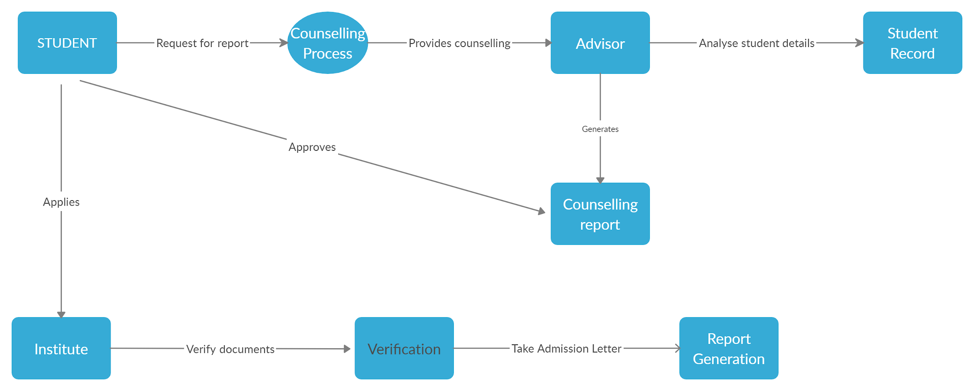

***System Requirements Specification***

***Assignment 2– SDP LAB (CS3036)***

***Personal Counselling System***

Department of Computer Engineering

**BRACT’S Vishwakarma Institute Technology**

***PUNE – 411 037***



*Prepared by:*

|  |  |  |  |
| --- | --- | --- | --- |
| **Name** | **Division** | **Roll Number** | **GR Number** |
| Riya Mate | T.Y. D | 8 | 1710954 |
| Neha Khare | T.Y. D | 18 | 1710176 |
| Aditi Patil | T.Y. D | 28 | 1710383 |
| Akshay Patil | T.Y. D | 29 | 1710456 |

*Approved by:*

|  |  |  |
| --- | --- | --- |
| ***Name*** | ***Signature*** | ***Date*** |
| *Prof. Mahesh Dube* |  | *30th Mar 2020* |

**TABLE OF CONTENTS**

|  |  |
| --- | --- |
| **TITLE** | **PAGE** |
| **1. Introduction** | 10 |
| * 1. Purpose | 11 |
| * 1. Scope | 12 |
| * 1. Abbreviations, Definitions & Acronyms | 13 |
| * 1. References | 13 |
| * 1. Overview | 14 |
| **2. Overall Description** | 15 |
| * 1. Problem Statement | 15 |
| * 1. Product Perspective | 15 |
| * 1. Product Position Statement | 15 |
| * 1. Software Interfaces | 16 |
| * 1. Hardware Interfaces | 16 |
| * 1. User Interfaces | 17 |
| * 1. Constraints | 18 |
| * 1. Assumptions & Dependencies | 18 |
| * 1. Product Functions | 18 |
| **Specific Requirements** | 19 |
| * 1. Product Hierarchy | 21 |
| * 1. Logical Databases | 21 |
| * 1. Non-functional Requirements | 22 |

# ***1. Introduction***

A System Requirements Specification has been viewed as a document that communicates the requirements of the customer to the technical community who will specify and build the system. The collection of requirements that constitutes the specification and its representation acts as the bridge between the two groups and must be understandable by both the customer and the technical community.

The first part of this document gives an overview and purpose of the ‘System Requirement Specification’ document. It describes the scope of the document and contains abbreviations, acronyms & definitions used throughout the document.

***1.1 Purpose***

The purpose of this document is to give insight into analysis and requirements of the system for determining the operating characteristics of the personal counselling system. The purpose is to define the overall vision and goals of this product, and to list those functional and non-functional requirements that are essential to the success of this product.

System Requirement Specification (SRS) provides a “Black-Box” description of what the system should do, in terms of the system’s interactions or interfaces with its external environment. The SRS organizes and communicates requirements to the customer and the technical community. It defines how our client, team and audience see the product and its functionality.

It will illustrate the complete declaration for the development of the system as well as constraints under which the system must operate, interface and interactions with other external applications. We shall predict and sort out how we hope this product will be used in order to gain a better understanding of the project, outline concepts that may be developed later, and document ideas that are being considered, but may be discarded as the product develops.

It establishes the basis for agreement between the customers and the suppliers on what the software product is to do. The complete description of the functions to be performed by the software specified in the SRS will assist the potential user to determine if the software specified meets their needs or how the software must be modified to meet their needs.

It provides a basis for developing the software design. The SRS is the most important document of reference in developing a design. It reduces the development effort. Careful review of the requirements in the SRS can reveal omissions, misunderstandings and inconsistencies early in the development cycle when these problems are easier to correct

Serve as a basis for enhancement. Because the SRS discusses the product but not the project that developed it, the SRS serves as a basis for later enhancement of the finished product. The SRS may need to be altered, but it does provide a foundation for continued product evaluation.

1.1.1 INTENDED AUDIENCE FOR SRS

* Institution Authorities that will use, own, and acquire the system.
* System architects who will describe, develop, and document architectures.
* Architects, designers, programmers, maintainers, testers, domain engineers, quality assurance staff, configuration management staff, suppliers, and project managers or developers who will develop, deliver, and maintain the system.

***1.2 Scope***

In order to improve the facilities related to counselling process, many other virtual counselling schemes came into actuality, which provisions the students in getting essential help about the educational procedures of universities and colleges. Counselling is the process that includes different types of activities such as guiding students towards colleges and universities, supporting them to register with their courses, providing full guidance in getting the information related to their college registration process. This online counselling system even gives great support to universities and colleges through which they can totally reduce the paper usage for counselling and guiding the students towards their university courses. Basically this software includes three different modules in which universities can manage their college records, student’s records as well as counselling sections.

***1.3 Abbreviations, Definitions & Acronyms***

|  |  |
| --- | --- |
| Term | Definition |
| System Requirements Specification (SRS) | A software requirements specification (SRS) is a document that captures a complete description about how the system is expected to perform. |
| User | An entity that utilizes the resources of the system as submitted by the system. Student and Institutes in this system. |
| Database (db.) | A database is a collection of information that is organized so that it can easily be accessed, managed, and updated. |
| Counselling | Guiding students to which institutes to apply based on his/her academic records and institutes’ merit lists. |
| Constraint | A well-defined condition or restriction. |
| Academic Record | Students’ academic results and marksheets. |
| Report | A result of the counselling process requested by the student |
| GUI | Graphical User Interface |
| OLEDB | Object Linking and Embedding Database |

***1.4.1 References***

* IEEE Recommended Practice for Architectural Description of Software-Intensive Systems, IEEE Std. 1471-2000.
* IEEE Recommended Practice for Software Requirements Specifications, IEEE Std. 830-1998.
* IEEE Guide for Developing System Requirements Specifications, IEEE Std. 1233-1998.

***1.4.2 Web References***

* PHP - <https://g.co/kgs/NJS68B>
* .NET Framework - <https://en.wikipedia.org/wiki/.NET_Framework>
* OLEDB - <https://en.wikipedia.org/wiki/OLE_DB>
* WinForms - <https://en.wikipedia.org/wiki/Windows_Forms>
* mySQL - <https://g.co/kgs/GG1kiR>

***1.5 Overview***

This part of the document covers Problem Statement, Product Position Statement which states for whom the product is intended to be developed. It includes hardware-software-communication as well as a User interfaces system. It mentions the system constraints, assumptions & dependencies about the product. It illustrates a summary of the major functions that the software will perform.

Final part is written primarily for the developers and describes in technical terms the details of the functionality of the product, the logical databases which the system includes & non-functional requirements system must provide.

***2. Overall Description***

***2.1 Problem Statement***

|  |  |
| --- | --- |
| The problem of | * Creating Student Profile * Creating Institute Profile * Providing help about educational procedures of universities and colleges. * Communication notification alerts |
| Affects | * Students and their parents * School organizations * College organizations |
| Impact of which | * Huge paper work * Delay in admission processes |
| Successful solution would be | * give great support to universities and colleges through which they can totally reduce the paper usage for counselling and guiding the students towards their university courses |

***2.2 Product Perspective***

* The ‘Personal Counselling System’ is an independent and self-contained system that manages student activities and counselling in an educational organization.
* It gives a procedural approach of creating student profile, counselling process and applying for institutes online..
* Various stakeholders are involved in this system.

***2.3 Product Position Statement***

|  |  |
| --- | --- |
| For | School and College Organizations |
| Who | Provides provisions the students in getting essential help about the educational procedures of universities and colleges |
| The Product | Personal Counselling System |
| That | Gives great support to universities and colleges through which they can totally reduce the paper usage for counselling and guiding the students towards their university courses |
| Our Product | improve the facilities related to counselling process, many other virtual counselling schemes came into actuality, which provisions the students in getting essential help about the educational procedures of universities and colleges |

***2.4 Software Requirements***

· Windows 7 or higher

· SQL 2008

· Visual studio 2019

***2.5 Hardware Components***

· Processor – i3 / i5 /i7

· Hard Disk – 5 GB

· Memory – 1GB RAM

· Internet Connection

***2.4 User Interfaces***

|  |  |
| --- | --- |
| Type | Interfaces |
|  |  |
| Student registration | Students can register to the system by providing all the details required for registration. |
| Modify student details | Students can modify the data entered during registration. |
| Institute Information | Display institute details to the students. |
| Edit/ Delete academic record | Students can edit/delete the academic record which will be processed by the institute. |
| Apply for Counselling | Student can apply for counselling process |
| Report | Students who have applied for counselling will get a report based on the results of the counselling process. |

***2.5 Constraints***

1.Student or student’s guardian/parent must have a mobile phone so as to receive notification alerts.

2. All the student records must be unique. It must be ensured that none of the newly recorded records are conflicting with the existing ones.

3. The data provided by the institutes should be up to date.

***2.6 Assumptions & Dependencies***

1. The computer system on which software is installed is assumed to have an uninterrupted power supply. In case the crashes due to power failure, the system will not be accessible until the power is restored.

2. Users are mobile literate in order to be able to read and interpret notification messages and emails.

3. Users are computer literate in order to be able to read and interpret notification emails.

4. The internet service is available in order to make use of the system

5. Entire database is backed up from time-to-time. This is required so that in case of data corruption, the database can be recovered from the backup.

6. The system will not be available when the system is being upgraded for installing the new OS, a new version of the System itself.

***2.7 Product Functions***

**Goal -1**: ***Create*** ***student profile***

1. The system will be able to add new student, edit existing student
2. The system shall provide details of all the students in the school / college institution.

**Goal -2**: ***Create*** ***institute profile***

1. The system will be able to add new student, edit existing institute information
2. The system shall provide details of all the school / college institutions present in the system.

**Goal -3**: ***Manage academic record***

1. The student will be able to add new academic records, edit existing academic records to the system.
2. The institute shall process the academic records.

**Goal -4**: ***Provide counselling***

1. The system shall provide counselling to the students.
2. The students can request for counselling.
3. The system advisor shall provide the career guide.

**Goal -5: *Generate Report***

1. The system will generate reports of students who underwent counselling.
2. The system will generate an online application for the institute chosen by the student***.***

|  |
| --- |
| 1. ***Developer Specific Requirement*** |

***3.1 Product Hierarchy***

**Goal -1**: ***Create student profile***

Objective 1: *Create new student profile*

Process 1: Students will register into the system by providing the necessary details like full name, DOB, address, phone no, e-mail, parents, information, etc.

Process 2: Student details will be stored into the Student Database.

Objective 2: *Update existing student profile*

Process 1: Students can modify the details provided during registration.

Process 2: The modifications will be reflected into the Student Database.

**Goal -2**: ***Create*** ***institute profile***

Objective 1: *Add new institute*

Process 1: Institute information will be added into the system.

Process 2: Institute information will be stored into the database.

Objective 2: *Display institute details*

Process 1: Display the information about the institute for the student to view.

**Goal -3**: ***Manage academic record***

Objective 1: *Edit/Delete academic records*

Process 1: Students shall upload the academic records to the system.

Process 2: Students can edit/delete the academic record if desired.

Objective 2: *Process academic record*

Process 1: Institutes process the academic record and generate a merit list.

**Goal -4**: ***Provide counselling***

Objective 1: *Accept student request*

Process 1: Student requests for career guidance

Objective 2: *Generate career guide*

Process 1: The academic records of the student are fetched.

Process 2: The records are compared with the merit list of institutes.

Process 3: The relevant courses to which the student can apply are sent back to the student.

**Goal -5: *Generate Report***

Objective 1: *Generate student report*

Process 1: The student report is generated after the counseling process.

Objective 2: *Generate online application*

Process 1: The student can apply to the institutes based on the counselling.

Process 2: The student can take admission in the institute if the application is approved.

***3.2 Logical Databases***

|  |  |
| --- | --- |
| Name | Purpose |
| Student Database | Student details which includes personal information, residential information, academic information, etc. |
| Institute Database | Institute details which includes information about the institute, courses provided by the institute, cut-off percentage for each of the courses for the past years. |
| Academic Record Database | Provides academic records of the student that will be processed by the institutes to decide whether the student can be admitted to the institute or not. |

***3.3 Non-Functional Requirements***

1) **Availability**

* “The degree to which a system, subsystem or equipment is in a specified operable and committable state at the start of a mission, when the mission is called for at an unknown, i.e. a random, time”
* The system will be available all the time.

2) **Security**

* “Security is the protection of information systems from theft or damage to the hardware, the software, and to the information on them, as well as from disruption or misdirection of the services they provide.”
* Some operations can be only authorized with the concerned institute’s or authority’s authentication.

3) **Reliability**

* “The probability of failure-free software operation for a specified period of time in a specified environment.”
* Reliability will be achieved through ensuring time-to-time backups of the system and data.
* In case of contingency, these backups can be used to restore the data in no time and the institute or academic record details will be affected to very less extent.

4) **Interoperability**

* “Interoperability is the ability of different information technology systems and software applications to communicate, exchange data, and use the information that has been exchanged.”
* Institute details will be available to all students and students’ academic record details will be available to the institute.

***Business Process Diagrams***

***Assignment 3– SDP LAB (CS3036)***

***Personal Counselling System***

Department of Computer Engineering

**BRACT’S Vishwakarma Institute Technology**

***PUNE – 411 037***



*Prepared by:*

|  |  |  |  |
| --- | --- | --- | --- |
| **Name** | **Division** | **Roll Number** | **GR Number** |
| Riya Mate | T.Y. D | 8 | 1710954 |
| Neha Khare | T.Y. D | 18 | 1710176 |
| Aditi Patil | T.Y. D | 28 | 1710383 |
| Akshay Patil | T.Y. D | 29 | 1710456 |

*Approved by:*

|  |  |  |
| --- | --- | --- |
| ***Name*** | ***Signature*** | ***Date*** |
| *Prof. Mahesh Dube* |  | *30 Sept 2016* |

**TABLE OF CONTENTS**

|  |  |
| --- | --- |
| **TITLE** | **PAGE** |
| **Business Process Diagrams** |  |
| 1. Create Student Profile | **26** |
| 2. Create Institute Profile | **26** |
| 3. Manage Academic Record | **27** |
| 4. Provide Counselling | **28** |
| 5.1. Generate Report | **29** |
| 5.2. Online Application | **29** |

|  |
| --- |
| ***BPD 1 - Create Student Profile*** |

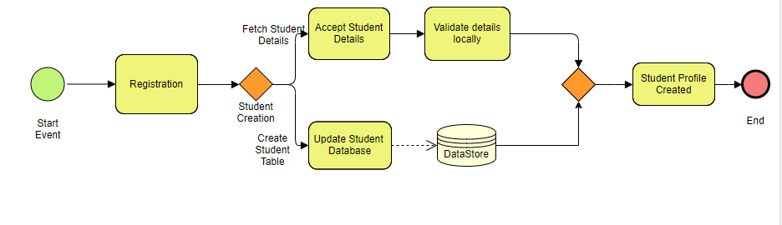

|  |
| --- |
| ***BPD 2 - Create Institute Profile*** |

## 

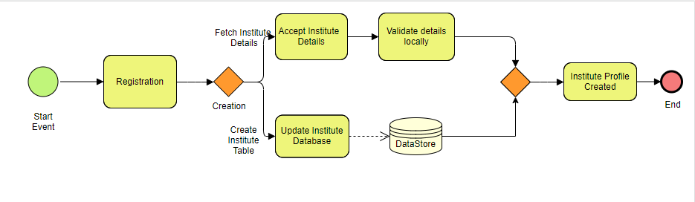

|  |
| --- |
| ***BPD 3 - Manage Academic Record*** |

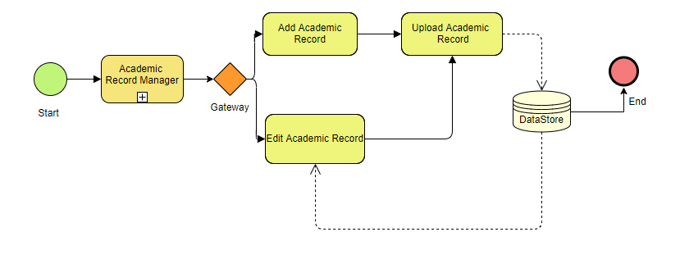

|  |
| --- |
| ***BPD 4 - Provide Counselling*** |

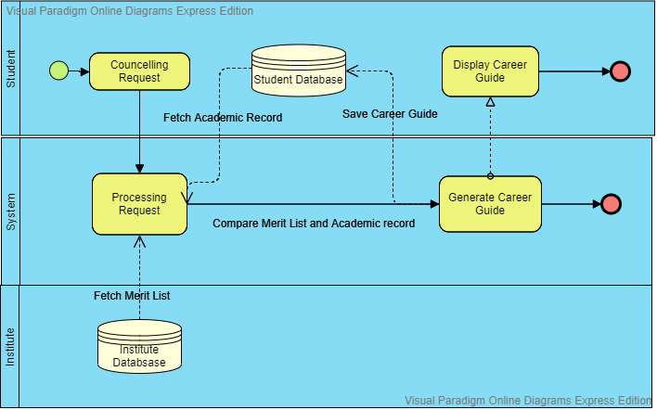

|  |
| --- |
| ***BPD 5.1 - Generate Report*** |

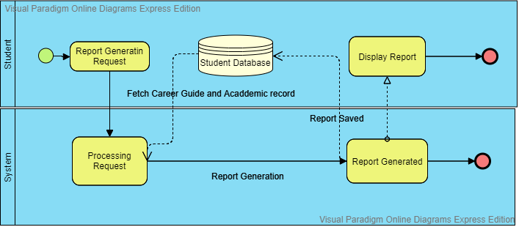

|  |
| --- |
| ***BPD 5.2 - Online Application*** |

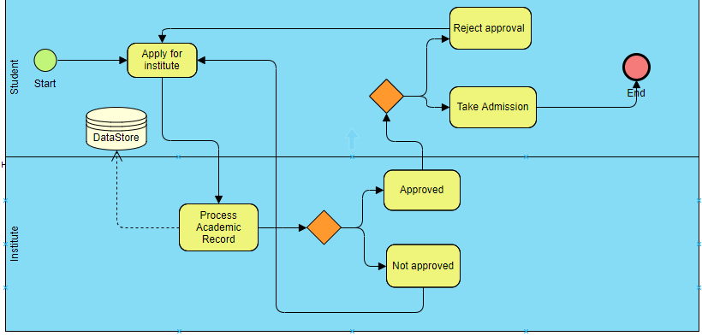

***Use Case Diagram***

***Assignment 4– SDP LAB (CS3036)***

***Personal Counselling System***

Department of Computer Engineering

**BRACT’S Vishwakarma Institute Technology**

***PUNE – 411 037***



*Prepared by:*

|  |  |  |  |
| --- | --- | --- | --- |
| **Name** | **Division** | **Roll Number** | **GR Number** |
| Riya Mate | T.Y. D | 8 | 1710954 |
| Neha Khare | T.Y. D | 18 | 1710176 |
| Aditi Patil | T.Y. D | 28 | 1710383 |
| Akshay Patil | T.Y. D | 29 | 1710456 |

*Approved by:*

|  |  |  |
| --- | --- | --- |
| ***Name*** | ***Signature*** | ***Date*** |
| *Prof. Mahesh Dube* |  | *30 Sept 2016* |

|  |  |
| --- | --- |
| **TITLE** | **PAGE** |
| 1. Introduction | 30 |
| 1. Use Case Technology | 30 |
| 1. Identifying components & relationships between Use Cases | 31 |
| 3.1. Identifying Actors | 31 |
| 3.2. Identifying Use Cases | 31 |
| 3.3. Relationship (Structuring) between Use Cases | 32 |
| 1. Actual Use Cases for “Personal counselling” | 32 |
| 4.1 Top Level System interactions with Actors | 33 |
| 4.2 Individual Use Cases | 34 |
| Use Case 1 | 34 |
| Use Case 2 | 43 |
| Use Case 3 | 59 |
| Use Case 4 | 68 |
| Use Case 5 | 75 |

# 

# ***Introduction***

A use case is a list of steps, typically defining interactions between a role (known in [Unified Modeling Language](http://en.wikipedia.org/wiki/Unified_Modeling_Language)(UML) as an "[actor](http://en.wikipedia.org/wiki/Actor_(UML))") and a system, to achieve a goal. The actor can be a human, an external system like database, or time.

A use case diagram at its simplest is a representation of a user's interaction with the system and depicting the specifications of a [use case](http://en.wikipedia.org/wiki/Use_Case). A use case diagram can portray the different types of users of a system and the various ways that they interact with the system.

Use cases can also be defined as a sequence of transactions performed by a system that yield a measurable set of values for a particular actor.

# ***Use Case Terminology***

* ***Use cases***. A use case describes a sequence of actions that provide something of measurable value to an actor and is drawn as a horizontal ellipse.
* ***Actors***. An actor is a person, organization, or external system that plays a role in one or more interactions with your system. Actors are drawn as stick figures.
* ***Associations***. Associations between actors and use cases are indicated in use case diagrams by solid lines. An association exists whenever an actor is involved with an interaction described by a use case. Associations are modeled as lines connecting use cases and actors to one another, with an optional arrowhead on one end of the line. The arrowhead is often used to indicate the direction of the initial invocation of the relationship or to indicate the primary actor within the use case. The arrowheads are typically confused with data flow and as a result their use should be avoided.
* ***System boundary boxes (optional).*** You can draw a rectangle around the use cases, called the system boundary box, to indicate the scope of your system. Anything within the box represents functionality that is in scope and anything outside the box is not. System boundary boxes are rarely used, although on occasion we have used them to identify which use cases will be delivered in each major release of a system.
* ***Packages (optional).*** Packages are UML constructs that enable you to organize model elements (such as use cases) into groups. Packages are depicted as file folders and can be used on any of the UML diagrams, including both use case diagrams and class diagrams. We use packages only when our diagrams become unwieldy, which generally implies they cannot be printed on a single page, to organize a large diagram into smaller ones.

# ***Identifying components & relationships between Use Cases***

## ***Identifying Actors***

Find the external entities with which the system under development must interact. Candidates include groups of users who will require help from the system to perform their tasks and run the system's primary or secondary functions, as well as external hardware, software, and other systems.

Define each candidate actor by naming it and writing a brief description. Includes the actor's area of responsibility and the goals that the actor will attempt to accomplish when using the system. Eliminate actor candidates who do not have any goals.

These questions are useful in identifying actors:

1. Who will supply, use, or remove information from the system?
2. Who will use the system?
3. Who is interested in a certain feature or service provided by the system?
4. Who will support and maintain the system?
5. What are the system's external resources?
6. What other systems will need to interact with the system under development?

## ***Identifying Use Cases***

The best way to find use cases is to consider what each actor requires of the system. For each actor, human or not, ask:

1. What are the goals that the actor will attempt to accomplish with the system?
2. What are the primary tasks that the actor wants the system to perform?
3. Will the actor create, store, change, remove, or read data in the system?
4. Will the actor need to inform the system about sudden external changes?
5. Does the actor need to be informed about certain occurrences, such as unavailability of a network resource, in the system?
6. Will the actor perform a system startup or shutdown?

Give a unique name and brief description that clearly describes the goals for each use case. If the candidate use case does not have goals, ask yourself why it exists, and then either identify a goal or eliminate the use case.

***For Personal Counselling, we have identified following main Use Cases:***

1. Process Student details
2. Process Institute details
3. Process Academic records
4. Counselling
5. Admission report generation

**System Scope:**

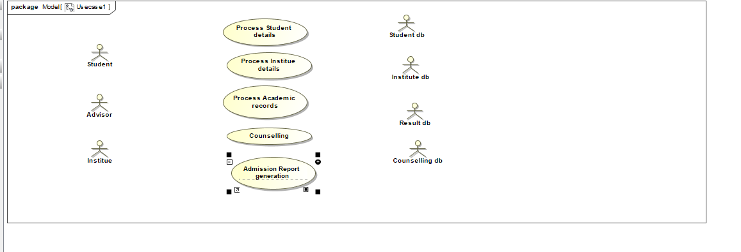

**Goal 1:**

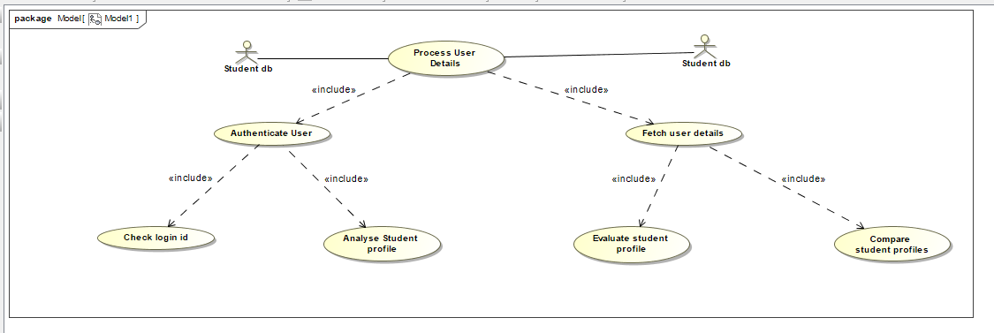

|  |  |  |
| --- | --- | --- |
| USE CASE #1.0 | ***Process Student Details*** | |
| ***Goal*** | Create a student profile inorder to provide counselling. | |
| ***Purpose*** | 1. Create a User Profile for counselling | |
| ***Preconditions*** | Users should know the valid authentication parameters (username, password) and have a valid contact number. | |
| ***Success Condition*** | Successful Created a student profile. | |
| ***Failed Condition*** | Failed to create a student profile. | |
| ***Post Conditions*** | Students will be able to access the system after only validation of user authentication parameters. | |
| ***Primary Actors*** | Student | |
| ***Secondary Actors*** | **Student Database** | |
| ***Trigger*** | Verify Primary Details | |
| ***DESCRIPTION*** | **Step** | ***Basic Course of Action*** |
|  | 1 | Student wants to access the system. |
|  | 2 | Search for the login webpage and load it on the screen. |
|  | 3 | Registration form is searched for new student registration. |
|  | 4 | The registration form will be displayed for creation of a user profile as a student if the user account is not already existing. |
|  | 5 | Login page will be loaded if the student account already exists. |
|  | 6 | Students enter basic information needed in the registration form. |
|  | 7 | The data is validated and if the data is correct then the data will be saved in the database. |
|  | 8 | If no username clashes with the entered username then registration is processed further. |
|  | 9 | System Loads two form on the screen:  Login and Sign Up |
|  | 10 | Login page is loaded if the student's account already exist. |
|  | 11 | Student enters login username and password. |
|  | 12 | Login records are fetched from the student database. |
|  | 13 | The entered details are checked whether they are present in fetched login records. |
|  | 14 | System access is provided to the student by logging him in the system. |
|  | 15 | Users select Login after sign Up is completed. |
| ***DESCRIPTION*** | **Step** | ***Alternate Course of Action*** |
|  | 1 | Allow users to modify details entered during the Registration Form. |
|  | 2 | System searches for alternate signup or login page. |
|  | 3 | Alternate registration page is loaded. |
|  | 4 | All available alternate registration or login options are searched. |
|  | 5 | Available options are displayed to the student. |
|  | 6 | Students enter the login details in the login page for alternate accounts. |
|  | 7 | Login details are forwarded to the alternate account server and they are checked for correctness. |
|  | 8 | If registration is successful then user details are retrieved from the alternate account. |
|  | 9 | Registration form is opened having details of the user prefilled in it. |
|  | 10 | Students modify any details if necessary and submit the registration form. |
|  | 11 | Student chooses a username and password for his new account. |
| ***DESCRIPTION*** | **Step** | ***Error Scenario*** |
|  | 1 | Invalid username and password. |
|  | 2 | The registration is incomplete. |
|  | 3 | Alternate accounts could not be connected. |
|  | 4 | Student account is unavailable. |

|  |  |  |
| --- | --- | --- |
| ***USE CASE #1.1*** | Authenticate Student | |
| ***Goal*** | The System shall verify a student profile. | |
| ***Purpose*** | To enable the student to access the system | |
| ***Primary Actors*** | Student | |
| ***Secondary Actors*** | Student Database | |
| ***Preconditions*** | The system shall be connected to the database. | |
| ***Post Conditions*** | The system shall authenticate the student profile and students can view their counselling report. | |
| ***DESCRIPTION*** | ***Step*** | ***Basic Course of Action*** |
|  | 1 | Student opens the application. |
|  | 2 | System provides login id. |
|  | 3 | Student selects the registration form provided by the system if not register |
|  | 4 | Student enters username and password. |
|  | 5 | System accepts the information that the student feeds. |
|  | 6 | Check for the availability of the User Name and it is not conflicting with other User. |
|  | 7 | System checks if the Password is entered in the format required. |
|  | 8 | Create the student profile into the system. |
|  | 9 | Validate the student by checking the correct information entered. |
|  | 10 | System creates server connection. |
|  | 11 | System sends the validation error if occurred. |
|  | 12 | System sends confirmation messages to the student’s email. |
| ***DESCRIPTION*** | ***Step*** | ***Alternate Course of Action*** |
|  | 1 | System asks the user to login. |
|  | 2 | User enters the mobile number. |
|  | 3 | OTP is generated randomly to verify the user. |
|  | 3 | OTP is sent to the registered mobile number. |
|  | 4 | OTP is verified if inserted correctly. |
|  | 5 | System compares the OTP entered by the user with the one sent by the system. |
|  | 6 | Students can access the system if OTP entered is valid. |
|  | 7 | Student acknowledges the success message. |
| ***DESCRIPTION*** | ***Step*** | ***Error Scenario*** |
|  | 1 | OTP entered is invalid. |

|  |  |  |
| --- | --- | --- |
| ***USE CASE #1.2*** | Fetch User Details | |
| ***Goal*** | The System shall allow the users to update their information such as name,home address,upload documents and other information. | |
| ***Purpose*** | System allows students to update student information,enter studentId and password and click the submit button. | |
| ***Primary Actors*** | Student | |
| ***Secondary Actors*** | Student Database | |
| ***Preconditions*** | The system shall be connected to the database. | |
| ***Post Conditions*** | Student has successfully updated the information | |
| ***DESCRIPTION*** | ***Step*** | ***Basic Course of Action*** |
|  | 1 | Student opens the application. |
|  | 2 | System provides login id. |
|  | 3 | System fetches the database of the user. |
|  | 4 | Current student information is displayed. |
|  | 5 | Student enters changes on change student details . |
|  | 6 | Changes are validated on the web server. |
|  | 7 | A Confirmation webpage is sent to the user. |
| ***DESCRIPTION*** | ***Step*** | ***Alternate Course of Action*** |
|  | 1 | System accepts the details of students. |
|  | 2 | System reviews the details of students |
|  | 3 | Change the details in the database locations. |
|  | 3 | System processes on the information taken into the system. |
|  | 4 | Student changes are noted. |
|  | 5 | Database is updated in case new documents are added. |
|  | 6 | Changes in the database must be verified. |
|  | 7 | Students acknowledge the success message of changes. |
| ***DESCRIPTION*** | ***Step*** | ***Error Scenario*** |
|  | 1 | Poor connectivity can lead to student details unchanged. |

BCA

|  |  |  |
| --- | --- | --- |
|  | **Service name** | **Scope** |
| 1 | Display Student Form () | Launch form for registering a new student in the system. |
| 2 | Process New Student Details () | Process the details entered by the students. |
| 3 | Handle Student ’s Registration() | Include the new student in the system. |
| 4 | Validate Student’s Registration() | Check whether the student is successfully registered in the system or not. |
| 5 | Fetch Student’s Profile () | Make active the student’s profile. |

|  |  |  |
| --- | --- | --- |
|  | **Responsibility name** | **Scope** |
| 1 | Search New Student Form() | Search and load the new student registration form |
| 2 | Check Student’s Details() | Validate details entered by the student. |
| 3 | Include New student() | Create new student profile |
| 4 | Generate Registration OTP() | Create and confirm registration using the OTP. |
| 5 | Generate Registration Time Stamp() | Record the time of registration of the new user. |

ACA

|  |  |  |
| --- | --- | --- |
|  | **Service name** | **Scope** |
| 1 | Display Signup Options() | Display all the alternate signup options to the student. |
| 2 | Load Alternate Signup Page() | Load the signup page for the alternate option. |
| 3 | Authenticate Alternate Sign Up() | Check the alternate signup account of the student.. |
| 4 | Launch Student’s Account() | Create the alternate signup account of the student.. |
| 5 | Acknowledge New Student() | Display students the success/failure of the operation. |

Error Scenario

|  |  |
| --- | --- |
|  | **Error Scenario** |
| 1 | Verify Username () |
| 2 | Verify Registration Details() |
| 3 | Check Alternate Account Server Connection() |
| 4 | Validate Generated OTP() |
| 5 | Verify User dB Availability() |

Goal 2:

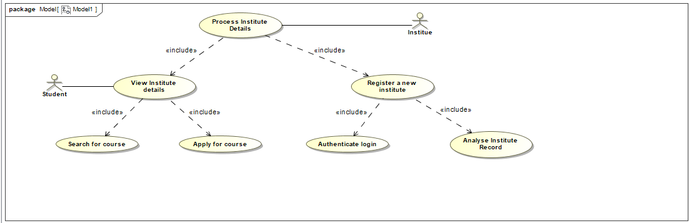

|  |  |  |
| --- | --- | --- |
| USE CASE #2.0 | ***Process Institute Details*** | |
| ***Goal*** | Create a university record. | |
| ***Purpose*** | 1.View Institute details  2.Register a new Institute | |
| ***Preconditions*** | Users should know the valid authentication parameters (username, password) and have a valid contact number. | |
| ***Success Condition*** | Successful registration of a university. | |
| ***Failed Condition*** | Failed to create a university profile.  Failed to display university details. | |
| ***Post Conditions*** | Institutes will be able to access the system after only validation of authentication parameters. | |
| ***Primary Actors*** | Institute | |
| ***Secondary Actors*** | **Institute Database** | |
| ***Trigger*** | Verify Primary Details | |
| ***DESCRIPTION*** | **Step** | ***Basic Course of Action*** |
|  | 1 | Institute record is to be maintained in the system. |
|  | 2 | New institute details are to be entered in the system. |
|  | 3 | Verified university details are recorded in the database. |
|  | 4 | University authentication is to be done. |
|  | 5 | Login page will be loaded if the university details are already present in the system. |
|  | 6 | Registration page is loaded in case university details are not present in the system. |
|  | 7 | The data is validated and if the data is correct then the data will be saved in the database. |
|  | 8 | University license is verified. |
|  | 9 | Institute details are stored in the database. |
|  | 10 | A message of successful university registration is displayed. |
|  | 11 | Student wants to see university details. |
|  | 12 | Student enters login username and password. |
|  | 13 | Login records are fetched from the student database. |
|  | 14 | The entered details are checked whether they are present in fetched login records. |
|  | 15 | Access to university details is given to the student. |
| ***DESCRIPTION*** | **Step** | ***Alternate Course of Action*** |
|  | 1 | Allows university to modify details entered during the Registration Form. |
|  | 2 | System searches for alternate signup or login page. |
|  | 3 | Alternate registration page is loaded. |
|  | 4 | All available alternate registration or login options are searched. |
|  | 5 | Available options are displayed to the respective university.. |
|  | 6 | Login details are entered in the login page for alternate accounts. |
|  | 7 | Login details are forwarded to the alternate account server and they are checked for correctness. |
|  | 8 | If registration is successful then university details are retrieved from the alternate account. |
|  | 9 | Registration form is opened having details of the institute prefilled in it. |
|  | 10 | University updates any details if necessary and submit the registration form. |
|  | 11 | Institute record is maintained. |
| ***DESCRIPTION*** | **Step** | ***Error Scenario*** |
|  | 1 | Institute details are incomplete. |
|  | 2 | Institute authentication has failed. |
|  | 3 | Alternate accounts could not be connected. |
|  | 4 | Student account is unavailable. |

|  |  |  |
| --- | --- | --- |
| USE CASE #2.1 | ***View Institute Details*** | |
| ***Goal*** | Display a university record. | |
| ***Purpose*** | View Institute details | |
| ***Preconditions*** | Users should know the valid authentication parameters (username, password) and have a valid contact number. | |
| ***Success Condition*** | Successful display of university record. | |
| ***Failed Condition*** | Failed to display university details. | |
| ***Post Conditions*** | Students will be able to access the system after only validation of authentication parameters. | |
| ***Primary Actors*** | Student | |
| ***Secondary Actors*** | **Institute Database** | |
| ***Trigger*** | Verify Primary Details | |
| ***DESCRIPTION*** | **Step** | ***Basic Course of Action*** |
|  | 1 | Institute record is to be displayed in the system. |
|  | 2 | Students need access to university details. |
|  | 3 | Student login is verified. |
|  | 4 | Student details are fetched from the student database. |
|  | 5 | Users search for the required university. |
|  | 6 | The system checks if the university exists in the system. |
|  | 7 | Institute record is fetched from the database. |
|  | 8 | The system displays the institute details to the student. |
|  | 9 | An invalid search message is displayed if the institute record is not available. |
|  | 10 | Student can access all the institute that offer a particular course |
|  | 11 | The course is searched in the database. |
|  | 12 | All institutes that registered the course are fetched from the database. |
|  | 13 | The list of institutes is displayed to the student. |
|  | 14 | Access to university details is given to the student. |
| ***DESCRIPTION*** | **Step** | ***Alternate Course of Action*** |
|  | 1 | Student searches for similar institutes that offer the course. |
|  | 2 | The information is fetched from the institute database. |
|  | 3 | Alternate institute details are loaded. |
|  | 4 | Institute details are filtered according to course specifications. |
|  | 5 | Available options are displayed to the respective student. |
|  | 6 | Institute details are loaded. |
|  | 7 | Search details are forwarded to the account server and they are checked for correctness. |
|  | 8 | If search is successful then university details are retrieved from the alternate account. |
| ***DESCRIPTION*** | **Step** | ***Error Scenario*** |
|  | 1 | Institute details are incomplete. |
|  | 2 | Institute authentication has failed. |
|  | 3 | Alternate accounts could not be connected. |
|  | 4 | Student account is unavailable. |

|  |  |  |
| --- | --- | --- |
| USE CASE #2.2 | ***Institute Registration*** | |
| ***Goal*** | Add a university record. | |
| ***Purpose*** | Add institute records. | |
| ***Preconditions*** | Institute should know the valid authentication parameters and a vaid university registration number. | |
| ***Success Condition*** | Successful addition of university record. | |
| ***Failed Condition*** | Failed to save university details. | |
| ***Post Conditions*** | University will be able to access the system after only validation of authentication parameters. | |
| ***Primary Actors*** | Institute | |
| ***Secondary Actors*** | **Institute Database** | |
| ***Trigger*** | Verify Primary Details | |
| ***DESCRIPTION*** | **Step** | ***Basic Course of Action*** |
|  | 1 | Institute record is to be added in the system. |
|  | 2 | Institute details are saved in the institute db |
|  | 3 | Institute login is verified. |
|  | 4 | Institute registration web page is loaded. |
|  | 5 | Connection to institute database. |
|  | 6 | Institute registration number is verified. |
|  | 7 | Institute record is entered. |
|  | 8 | The system displays the institute details to the student. |
| ***DESCRIPTION*** | **Step** | ***Alternate Course of Action*** |
|  | 1 | Institute requests for verification incase login fails. |
|  | 2 | The institute registration number is fetched from the institute database. |
|  | 3 | Password setup link is sent to the registered email id. |
|  | 4 | Alternate verification form for login is loaded. |
|  | 5 | Institute admin password is reset. |
|  | 6 | Admin is directed towards the login page. |
|  | 7 | Institute details are then entered. |
|  | 8 | Institute details are saved in the database. |
| ***DESCRIPTION*** | **Step** | ***Error Scenario*** |
|  | 1 | Institute details are incomplete. |
|  | 2 | Institute authentication has failed. |
|  | 3 | Alternate accounts could not be connected. |
|  | 4 | Student account is unavailable. |

BCA

|  |  |  |
| --- | --- | --- |
|  | **Service name** | **Scope** |
| 1 | Display Institute Form () | Launch form for registering a new institutet in the system. |
| 2 | Process New Institute Details () | Process the details entered by the universities.. |
| 3 | Handle Institute’s Registration() | Include the new institute in the system. |
| 4 | Validate Institute’s Registration() | Check whether the institute is successfully registered in the system or not. |
| 5 | Fetch Institute’s Profile () | Make active the institute’s profile. |

|  |  |  |
| --- | --- | --- |
|  | **Responsibility name** | **Scope** |
| 1 | Search New Institute Form() | Search and load the new institute registration form |
| 2 | Check Institute’s Details() | Validate details entered by the institute. |
| 3 | Include New institutet() | Create new institute profile |
| 4 | Generate Registration OTP() | Create and confirm registration using the OTP. |
| 5 | Generate Registration Time Stamp() | Record the time of registration of the new institute. |

ACA

|  |  |  |
| --- | --- | --- |
|  | **Service name** | **Scope** |
| 1 | Display Signup Options() | Display all the alternate signup options to the institute. |
| 2 | Load Alternate Signup Page() | Load the signup page for the alternate option. |
| 3 | Authenticate Alternate Sign Up() | Check the alternate signup account of the institute.. |
| 4 | Launch Institute’s Account() | Create the alternate signup account of the institute.. |
| 5 | Acknowledge New Institute() | Display institute the success/failure of the operation. |

Error Scenario

|  |  |
| --- | --- |
|  | **Error Scenario** |
| 1 | Verify Username () |
| 2 | Verify Registration Details() |
| 3 | Check Alternate Account Server Connection() |
| 4 | Validate Generated OTP() |
| 5 | Verify User dB Availability() |

Goal 3:

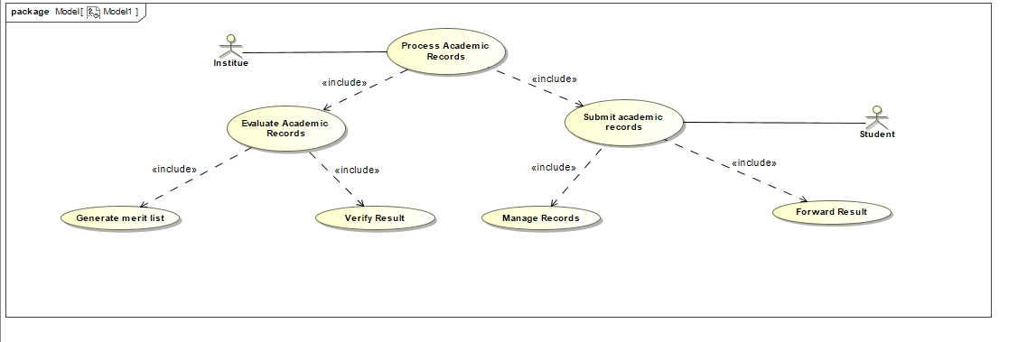

|  |  |  |
| --- | --- | --- |
| ***USE CASE #3.0*** | Process academic records | |
| ***Goal*** | The System shall allow the users to process academic records. | |
| ***Purpose*** | 1.System shall enable students to upload results  2.Institutes process academic records. | |
| ***Primary Actors*** | Student | |
| ***Secondary Actors*** | Institute Database | |
| ***Preconditions*** | The system shall be connected to the database. | |
| ***Post Conditions*** | 1.Student has successfully uploaded academic records.  2.Merit list is published. | |
| ***DESCRIPTION*** | ***Step*** | ***Basic Course of Action*** |
|  | 1 | Student opens the application. |
|  | 2 | System provides login id. |
|  | 3 | System fetches the database of the user. |
|  | 4 | Current student information is displayed. |
|  | 5 | Student uploads academic record. |
|  | 6 | Changes are validated on the web server. |
|  | 7 | A Confirmation webpage is sent to the user. |
|  | 8 | Institutes evaluate multiple academic records |
|  | 9 | Academic records are fetched from the database. |
|  | 10 | A merit list is published. |
| ***DESCRIPTION*** | ***Step*** | ***Alternate Course of Action*** |
|  | 1 | System accepts the details of students. |
|  | 2 | User wants to delete a particular document. |
|  | 3 | Change the details in the database locations. |
|  | 3 | System processes on the information taken into the system. |
|  | 4 | Student changes are noted. |
|  | 5 | Database is updated in case new documents are added. |
|  | 6 | Changes in the database must be verified. |
|  | 7 | Students acknowledge the success message of changes. |
| ***DESCRIPTION*** | ***Step*** | ***Error Scenario*** |
|  | 1 | Merit list is not updated in the database. |
|  | 2 | Poor connectivity can lead to student details unchanged. |

|  |  |  |
| --- | --- | --- |
| ***USE CASE #3.1*** | Submit Academic Records. | |
| ***Goal*** | The System shall allow the users to upload and update academic records. | |
| ***Purpose*** | Upload academic records. | |
| ***Primary Actors*** | Student | |
| ***Secondary Actors*** | Student Database | |
| ***Preconditions*** | The system shall be connected to the database. | |
| ***Post Conditions*** | Student has successfully updated the information and forwarded it to institutes. | |
| ***DESCRIPTION*** | ***Step*** | ***Basic Course of Action*** |
|  | 1 | Student opens the application. |
|  | 2 | System provides login id. |
|  | 3 | System fetches the database of the user. |
|  | 4 | Current student information is displayed. |
|  | 5 | Student enters changes on change student details . |
|  | 6 | Changes are validated on the web server. |
|  | 7 | A Confirmation webpage is sent to the user. |
| ***DESCRIPTION*** | ***Step*** | ***Alternate Course of Action*** |
|  | 1 | User wants to delete a particular academic record. |
|  | 2 | System reviews the details of students |
|  | 3 | Change the details in the database locations. |
|  | 3 | System processes on the information taken into the system. |
|  | 4 | Student changes are noted. |
|  | 5 | Database is updated in case documents are deleted. |
|  | 6 | Changes in the database must be verified. |
|  | 7 | Students acknowledge the success message of changes. |
| ***DESCRIPTION*** | ***Step*** | ***Error Scenario*** |
|  | 1 | Academic records are not stored in the database. |

|  |  |  |
| --- | --- | --- |
| ***USE CASE #3.2*** | Evaluate academic records | |
| ***Goal*** | The System shall allow the institutes to process academic records. | |
| ***Purpose*** | 1.Institutes process academic records.  2.Merit list is published. | |
| ***Primary Actors*** | Institute | |
| ***Secondary Actors*** | Institute Database | |
| ***Preconditions*** | The system shall be connected to the database. | |
| ***Post Conditions*** | Merit list is published. | |
| ***DESCRIPTION*** | ***Step*** | ***Basic Course of Action*** |
|  | 1 | System processes academic records. |
|  | 2 | System provides login id. |
|  | 3 | System fetches the academic records from the database.. |
|  | 4 | Merit list is generated. |
|  | 5 | Multiple student records are compared. |
|  | 6 | Merit list is published. |
|  | 7 | Students access the merit list. |
| ***DESCRIPTION*** | ***Step*** | ***Alternate Course of Action*** |
|  | 1 | Institute fetches details of academic records based on various filters. |
|  | 2 | Institute applies filter to the academic record. |
|  | 3 | System processes on the information taken into the system. |
|  | 4 | Merit list is then applied to selected student records. |
|  | 5 | Merit list is generated. |
|  | 6 | Changes in the database must be verified. |
|  | 7 | Students access the merit list.. |
| ***DESCRIPTION*** | ***Step*** | ***Error Scenario*** |
|  | 1 | Merit list is not updated in the database. |
|  | 2 | Poor connectivity can lead to student details unchanged. |

BCA

|  |  |  |
| --- | --- | --- |
|  | **Service name** | **Scope** |
| 1 | Display Academic Record form() | Launch form for uploading academic details. |
| 2 | Submit Academic Record() | Enter the details in the academic record. |
| 3 | Evaluate Academic Report() | Process academic details.. |
| 4 | Validate Academic record() | Check whether the record is successfully registered in the system or not. |

|  |  |  |
| --- | --- | --- |
|  | **Responsibility name** | **Scope** |
| 1 | Upload academic record() | Search and load academic record form() |
| 2 | Check Record’s Details() | Validate the records.. |
| 5 | Evaluate Record() | Evaluate the student record. |

ACA

|  |  |  |
| --- | --- | --- |
|  | **Service name** | **Scope** |
| 1 | Manipulate academic details() | Display all the alternate options to the student.. |
| 2 | Load Alternate Update record Page() | Load the page for uploading the documents. |
| 3 | Authenticate new documents() | Authenticate new documents uploaded by the student |

Error Scenario

|  |  |
| --- | --- |
|  | **Error Scenario** |
| 1 | Verify Academic record () |
| 2 | Check Alternate Account Server Connection() |
| 3 | Update Meritlist() |
| 4 | Verify Institute dB Availability() |

Goal 4:

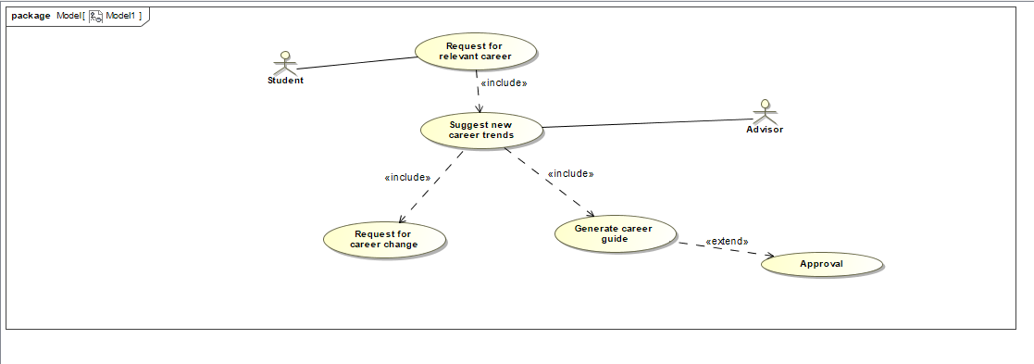

|  |  |  |
| --- | --- | --- |
| ***USE CASE #4.0*** | Counselling | |
| ***Goal*** | The System shall allow the advisors to provide counselling. | |
| ***Purpose*** | 1.Students request for counselling.  2.Advisors generate career guide.. | |
| ***Primary Actors*** | Advisor | |
| ***Secondary Actors*** | Student database | |
| ***Preconditions*** | The system shall be connected to the database. | |
| ***Post Conditions*** | Career guide is generated | |
| ***DESCRIPTION*** | ***Step*** | ***Basic Course of Action*** |
|  | 1 | Student requests for career guidance. |
|  | 2 | System provides login id. |
|  | 3 | System fetches the academic records from the database.. |
|  | 4 | Advisor logs in the system. |
|  | 5 | Student records are evaluated. |
|  | 6 | Academic record is compared according to merit list. |
|  | 7 | Advisor fetches relevant courses from the database |
|  | 8 | Student profile is matched accordingly. |
|  | 9 | Career guide is generated. |
|  | 10 | Students access the guide. |
|  | 11 | Guide report is then approved by the registered user. |
| ***DESCRIPTION*** | ***Step*** | ***Alternate Course of Action*** |
|  | 1 | Student request for another suggestion if not approved. |
|  | 2 | Student details are further examined. |
|  | 3 | Alternate career options are fetched from the database. |
|  | 4 | Revised report is sent to the student. |
|  | 5 | Students access the report. |
|  | 6 | Changes in the database must be verified. |
| ***DESCRIPTION*** | ***Step*** | ***Error Scenario*** |
|  | 1 | Request is not processed. |
|  | 2 | Invalid report generation. |

|  |  |  |
| --- | --- | --- |
| ***USE CASE #4.1*** | Request for career guidance | |
| ***Goal*** | The System shall allow the students to access counselling. | |
| ***Purpose*** | .Students request for counselling. | |
| ***Primary Actors*** | Student | |
| ***Secondary Actors*** | Advisor | |
| ***Preconditions*** | The system shall be connected to the database. | |
| ***Post Conditions*** | Request is accepted | |
| ***DESCRIPTION*** | ***Step*** | ***Basic Course of Action*** |
|  | 1 | Student requests for career guidance. |
|  | 2 | System provides login id. |
|  | 3 | System fetches the academic records from the database.. |
|  | 4 | Advisor logs in the system. |
|  | 5 | Student records are evaluated. |
|  | 6 | Student career interest web page is loaded. |
|  | 7 | Students enter academic interests. |
|  | 8 | Student profile is matched accordingly. |
|  | 9 | Details are stored in the database. |
|  | 10 | Advisor is notified about the request. |
|  | 11 | Student profile is sent for review to the advisor. |
| ***DESCRIPTION*** | ***Step*** | ***Alternate Course of Action*** |
|  | 1 | Student request for another suggestion if not approved. |
|  | 2 | Student details are further examined. |
|  | 3 | Alternate career options are fetched from the database. |
|  | 4 | Revised report is sent to the student. |
|  | 5 | Students access the report. |
|  | 6 | Changes in the database must be verified. |
| ***DESCRIPTION*** | ***Step*** | ***Error Scenario*** |
|  | 1 | Request is not processed. |
|  | 2 | Invalid report generation. |

|  |  |  |
| --- | --- | --- |
| ***USE CASE #4.2*** | Generate Career guide | |
| ***Goal*** | The System shall allow the advisors to provide a career guide. | |
| ***Purpose*** | Advisors generate career guide. | |
| ***Primary Actors*** | Advisor | |
| ***Secondary Actors*** | Student database | |
| ***Preconditions*** | The system shall be connected to the database. | |
| ***Post Conditions*** | 1.Career guide is generated.  2.Approval of the career guide. | |
| ***DESCRIPTION*** | ***Step*** | ***Basic Course of Action*** |
|  | 1 | Advisor is notified about the student request. |
|  | 2 | System provides login id. |
|  | 3 | Advisor logs in the system. |
|  | 4 | Student records is retrieved from the system |
|  | 6 | Academic record is compared according to merit list. |
|  | 7 | Advisor fetches relevant courses from the database. |
|  | 8 | Student profile is matched accordingly. |
|  | 9 | Career guide is generated. |
|  | 10 | Students access the guide. |
|  | 11 | Guide report is then approved by the registered user. |
| ***DESCRIPTION*** | ***Step*** | ***Alternate Course of Action*** |
|  | 1 | Student request for another suggestion if not approved. |
|  | 2 | Student details are further examined. |
|  | 3 | Alternate career options are fetched from the database. |
|  | 4 | Revised report is sent to the student. |
|  | 5 | Students access the report. |
|  | 6 | Changes in the database must be verified. |
| ***DESCRIPTION*** | ***Step*** | ***Error Scenario*** |
|  | 1 | Request is not processed. |
|  | 2 | Invalid report generation. |

Goal 5:

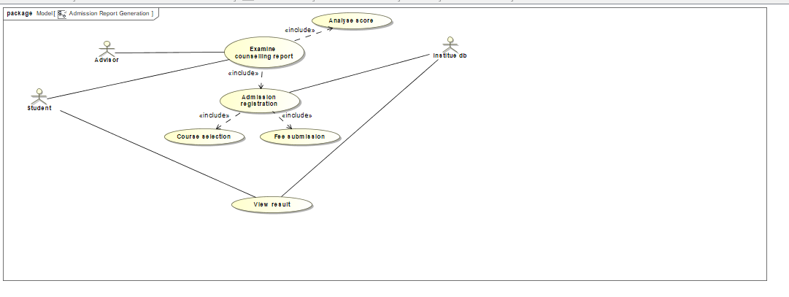

|  |  |  |
| --- | --- | --- |
| ***USE CASE #5.0*** | Admission report generation | |
| ***Goal*** | The System shall provide a final admission report for a student. | |
| ***Purpose*** | 1.Online application to an institute after counselling.  2.Result generation | |
| ***Primary Actors*** | Student | |
| ***Secondary Actors*** | Institute db | |
| ***Preconditions*** | The system shall be connected to the database. | |
| ***Post Conditions*** | 1.Successful admission to institute.  2.Result generation | |
| ***DESCRIPTION*** | ***Step*** | ***Basic Course of Action*** |
|  | 1 | Student examines the counselling report. |
|  | 2 | Students apply to the institute. |
|  | 3 | Student details are retrieved. |
|  | 4 | Students select a course. |
|  | 6 | Student pay the admission fee by entering bank details. |
|  | 7 | System verifies the student details. |
|  | 8 | Student profile is analysed by the institute. |
|  | 9 | Verification is sent to the student. |
|  | 10 | Students acknowledge the conformation message. |
|  | 11 | Admission report is generated. |
| ***DESCRIPTION*** | ***Step*** | ***Alternate Course of Action*** |
|  | 1 | Student request for another suggestion if admission is not approved.. |
|  | 2 | Student details are further examined. |
|  | 3 | Alternate institute options are fetched from the database. |
|  | 4 | Revised merit list is sent to the student. |
|  | 5 | Students access the report. |
|  | 6 | Students complete further application by applying to suggested institutes. |
| ***DESCRIPTION*** | ***Step*** | ***Error Scenario*** |
|  | 1 | Admission is not processed. |
|  | 2 | Admission deadline is not followed. |

|  |  |  |
| --- | --- | --- |
| ***USE CASE #5.1*** | Admission Registration | |
| ***Goal*** | The System shall allow the students to apply to universities after counselling report generation. | |
| ***Purpose*** | Application to an institute. | |
| ***Primary Actors*** | Student | |
| ***Secondary Actors*** | Institute database | |
| ***Preconditions*** | 1.Student is logged in.  2.Career guide is generated. | |
| ***Post Conditions*** | Successful application | |
| ***DESCRIPTION*** | ***Step*** | ***Basic Course of Action*** |
|  | 1 | Students access the system. |
|  | 2 | System enquiries login id. |
|  | 3 | User enters username and password. |
|  | 4 | Student career guide is loaded. |
|  | 5 | Institute registration form is loaded. |
|  | 6 | Student proceeds with the application. |
|  | 7 | Student selects the course. |
|  | 8 | Student completes the payment of fees. |
|  | 9 | Confirmation of admission is sent. |
| ***DESCRIPTION*** | ***Step*** | ***Alternate Course of Action*** |
|  | 1 | Student request for change in course after application. |
|  | 2 | Student details are further examined for approval. |
|  | 3 | Updated merit list is checked for vacancy. |
|  | 4 | Approval of course change is sent if request is approved. |
|  | 5 | Students acknowledge the admission confirmation. |
|  | 6 | Institute database is updated accordingly. |
| ***DESCRIPTION*** | ***Step*** | ***Error Scenario*** |
|  | 1 | Incomplete student profile. |
|  | 2 | Failure in updating the database for merit list generation. |

BCA

|  |  |  |
| --- | --- | --- |
|  | **Service name** | **Scope** |
| 1 | Student login() | Student logs in. |
| 2 | Analyse student report() | Process academic details.. |
| 3. | Request Admission() | Student applies to the institute. |

|  |  |  |
| --- | --- | --- |
|  | **Responsibility name** | **Scope** |
| 1 | Forward Admission letter() | Institute accepts the admission letter |
| 2 | Notify student() | Student acknowledges the admission. |

ACA

|  |  |  |
| --- | --- | --- |
|  | **Service name** | **Scope** |
| 1 | Apply to another institute() | Student applies to another institute. |
| 2 | Analyse report() | Generate alternate detailed institute list. |

Error Scenario

|  |  |
| --- | --- |
|  | **Error Scenario** |
| 1 | Failure in updating admission report. |
| 2 | Admission rejected. |

***Sequence Diagrams***

***Assignment 5 – SDP LAB (CS3036)***

***Personal Counselling System***

Department of Computer Engineering

**BRACT’S Vishwakarma Institute Technology**

***PUNE – 411 037***



*Prepared by:*

|  |  |  |  |
| --- | --- | --- | --- |
| **Name** | **Division** | **Roll Number** | **GR Number** |
| Riya Mate | T.Y. D | 8 | 1710954 |
| Neha Khare | T.Y. D | 18 | 1710176 |
| Aditi Patil | T.Y. D | 28 | 1710383 |
| Akshay Patil | T.Y. D | 29 | 1710456 |

*Approved by:*

|  |  |  |
| --- | --- | --- |
| ***Name*** | ***Signature*** | ***Date*** |
| *Prof. Mahesh Dube* |  | *30th Mar 2020* |

**TABLE OF CONTENTS**

|  |  |
| --- | --- |
| **TITLE** | **PAGE** |
| **Introduction** | 81 |
| **UML Sequence Diagram Terminology** | 81 |
| **Identifying Components of Sequence Diagrams** | 82 |
| * 1. Lifeline | 82 |
| ii. Message | 83 |
| A**ctual Sequence Diagrams for “Student Counselling”** | 84 |
| 1. Sequence Diagram for Student Login And Registration | 84 |
| 2.1 Sequence Diagram for Institute Registration | 87 |
| 2.2 Sequence Diagram for Viewing Institute Details | 88 |
| 3.1 Sequence Diagram for Uploading Academic Record | 91 |
| 3.2 Sequence Diagram for Generating Marklist | 92 |
| 4.1 Sequence Diagram for Career Guidance Report | 94 |
| 4.2 Sequence Diagram for Career Advice Report | 95 |
| 5.1 Sequence Diagram for Admission | 97 |

# ***Introduction***

**Sequence diagram** is the most common kind of [interaction diagram](http://www.uml-diagrams.org/uml-25-diagrams.html#interaction-diagram), which focuses on the [message](http://www.uml-diagrams.org/sequence-diagrams.html#message) interchange between a number of [lifelines](http://www.uml-diagrams.org/sequence-diagrams.html#lifeline).

Sequence diagram describes an interaction by focusing on the sequence of messages that are exchanged, along with their corresponding occurrence specifications on the lifelines.

The following nodes and edges are typically drawn in a **UML** **sequence diagram**: [lifeline](http://www.uml-diagrams.org/sequence-diagrams.html#lifeline), [execution specification](http://www.uml-diagrams.org/sequence-diagrams.html#execution), [message](http://www.uml-diagrams.org/sequence-diagrams.html#message), [combined fragment](http://www.uml-diagrams.org/sequence-diagrams-combined-fragment.html), [interaction use](http://www.uml-diagrams.org/sequence-diagrams.html#interaction-use), [state invariant](http://www.uml-diagrams.org/sequence-diagrams.html#state-invariant), **continuation**, [destruction occurrence](http://www.uml-diagrams.org/sequence-diagrams.html#destruction-occurrence-seq).

# ***UML Sequence Diagram Terminology***

Following diagram illustrates all the terminology used in UML sequence diagram.

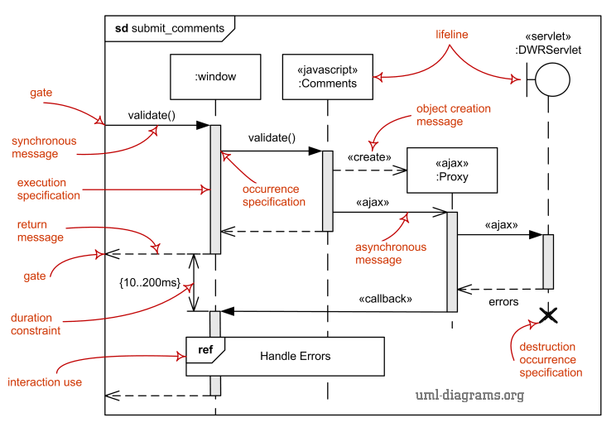

# ***Identifying components of Sequence Diagram***

## ***Lifeline***

Lifeline is a [named element](http://www.uml-diagrams.org/uml-core.html#named-element) which represents an individual participant in the interaction. While [parts](http://www.uml-diagrams.org/composite-structure-diagrams.html#part) and structural features may have multiplicity greater than 1, lifelines represent only one interacting entity.

A lifeline is shown using a symbol that consists of a rectangle forming its "head" followed by a vertical line (which may be dashed) that represents the lifetime of the participant. The lifeline head has a shape that is based on the [classifier](http://www.uml-diagrams.org/classifier.html) for the part that this lifeline represents. Usually the head is a white rectangle containing name of class.

Examples:

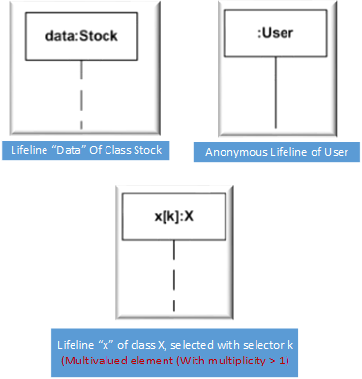

## ***Message***

Message is a [named element](http://www.uml-diagrams.org/uml-core.html#named-element) that defines one specific kind of communication between [lifelines](http://www.uml-diagrams.org/sequence-diagrams.html#lifeline) of an interaction. The message specifies not only the kind of communication, but also the sender and the receiver. Sender and receiver are normally two occurrence specifications (points at the ends of messages).

A message reflects either an [operation](http://www.uml-diagrams.org/class-diagrams.html#operation) call and start of execution or a sending and reception of a [signal](http://www.uml-diagrams.org/common-behaviors.html#signal).

When a message represents an operation call, the arguments of the message are the arguments of the operation. When a message represents a signal, the arguments of the message are the attributes of the signal.

Depending on the type of [action](http://www.uml-diagrams.org/activity-diagrams-actions.html) that was used to generate the message, message could be one of:

1. [Synchronous call](http://www.uml-diagrams.org/sequence-diagrams.html#synchronous-call)
2. [Asynchronous call](http://www.uml-diagrams.org/sequence-diagrams.html#asynchronous-call)
3. [C](http://www.uml-diagrams.org/sequence-diagrams.html#create)reate, Delete, Reply Messages

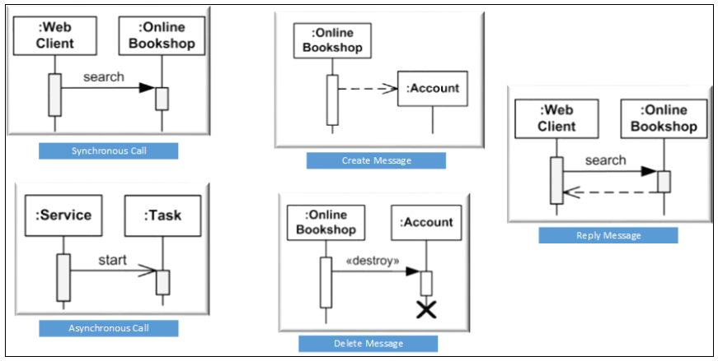

# ***Sequence Diagrams for Student Counselling System***

1. **Sequence Diagram for Student Login And Registration**

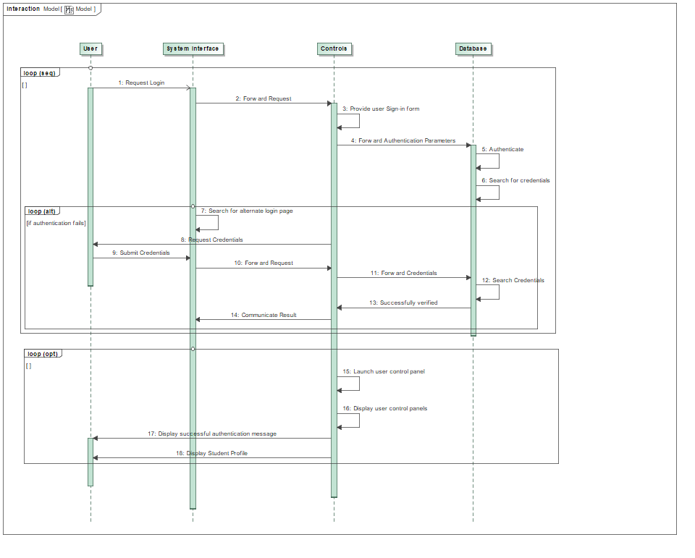

**BCA**

|  |  |  |
| --- | --- | --- |
|  | **Service name** | **Scope** |
|  |  |  |
| 1 | Login request() | Display login form. |
| 2 | Process New Institute Details () | Process the details entered by the universities.. |
| 3 | Handle Institute’s Registration() | Include the new institute in the system. |
| 4 | Validate Institute’s Registration() | Check whether the institute is successfully registered in the system or not. |
| 5 | Send course details() | Add new courses |

|  |  |  |
| --- | --- | --- |
|  | **Responsibility name** | **Scope** |
| 1 | Search New Institute Form() | Search and load the new institute registration form |
| 2 | Check Institute’s Details() | Validate details entered by the institute. |
| 3 | Include New institutet() | Create new institute profile |
| 4 | Generate Registration OTP() | Create and confirm registration using the OTP. |
| 5 | Generate Registration Time Stamp() | Record the time of registration of the new institute. |

ACA

|  |  |  |
| --- | --- | --- |
|  | **Service name** | **Scope** |
| 1 | Display Signup Options() | Display all the alternate signup options to the institute. |
| 2 | Load Alternate Signup Page() | Load the signup page for the alternate option. |
| 3 | Authenticate Alternate Sign Up() | Check the alternate signup account of the institute.. |
| 4 | Launch Institute’s Account() | Create the alternate signup account of the institute.. |
| 5 | Communicate Results() | Display institute the success/failure of the operation. |

**2.1 Sequence Diagram for Institute Registration**

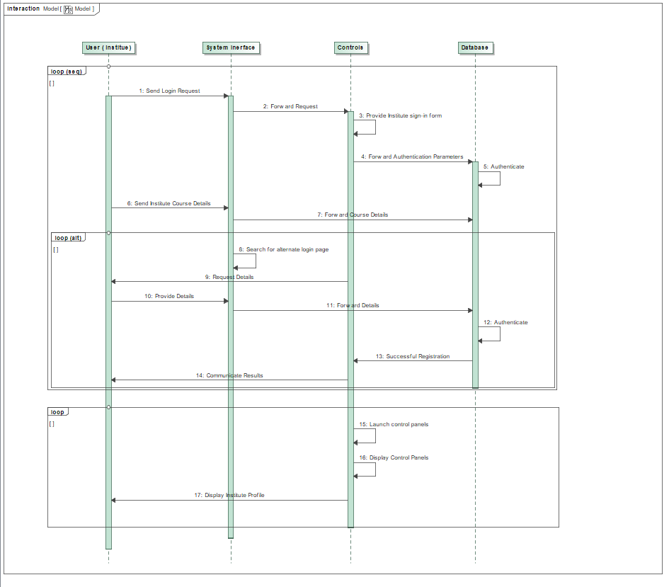

**Sequence Diagram for Viewing Institute Details**

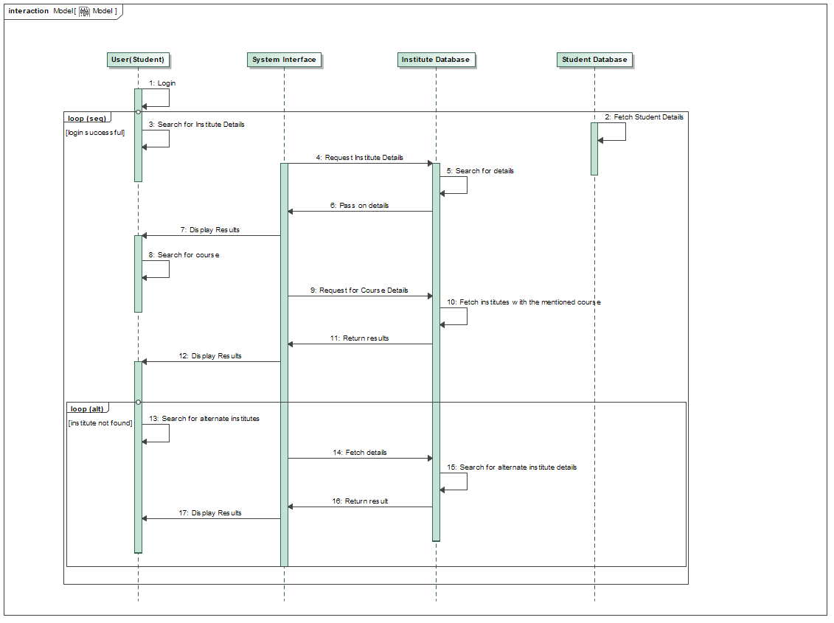

BCA

|  |  |  |
| --- | --- | --- |
|  | **Service name** | **Scope** |
| 1 | Login request() | Display login form. |
| 2 | Process New Institute Details () | Process the details entered by the universities.. |
| 3 | Handle Institute’s Registration() | Include the new institute in the system. |
| 4 | Validate Institute’s Registration() | Check whether the institute is successfully registered in the system or not. |
| 5 | Send course details() | Add new courses |

|  |  |  |
| --- | --- | --- |
|  | **Responsibility name** | **Scope** |
| 1 | Search New Institute Form() | Search and load the new institute registration form |
| 2 | Check Institute’s Details() | Validate details entered by the institute. |
| 3 | Include New institutet() | Create new institute profile |
| 4 | Generate Registration OTP() | Create and confirm registration using the OTP. |
| 5 | Generate Registration Time Stamp() | Record the time of registration of the new institute. |

ACA

|  |  |  |
| --- | --- | --- |
|  | **Service name** | **Scope** |
| 1 | Display Signup Options() | Display all the alternate signup options to the institute. |
| 2 | Load Alternate Signup Page() | Load the signup page for the alternate option. |
| 3 | Search Alternate institutes() | Check the alternate institutes that offer the same course. |
| 4 | Launch Institute’s Account() | Create the alternate signup account of the institute.. |
| 5 | Communicate Results() | Display institute the success/failure of the operation. |

**Sequence Diagram for Uploading Academic Record**

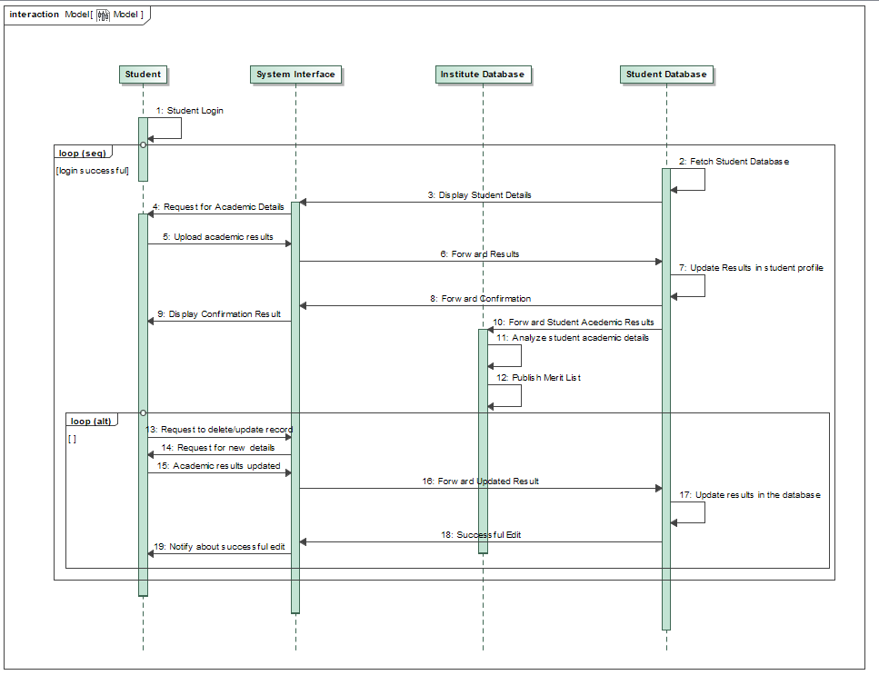

**3.2 Sequence Diagram for Generating Marklist**

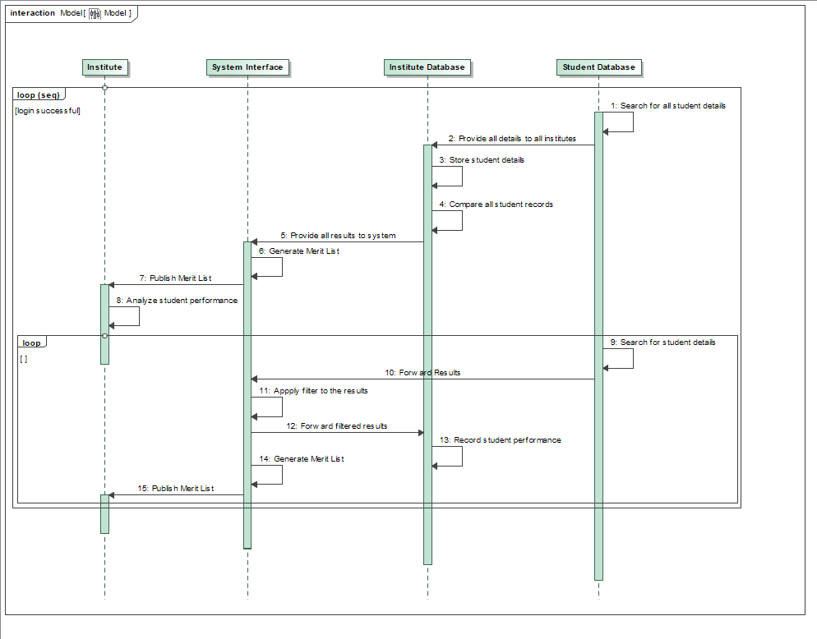

BCA

|  |  |  |
| --- | --- | --- |
|  | **Service name** | **Scope** |
| 1 | Request Academic details() | Launch form for uploading academic details. |
| 2 | Upload Academic Records() | Enter the details in the academic record. |
| 3 | Validate Academic record() | Check whether the record is successfully registered in the system or not. |
| 4 | Publish Merit List() | Process academic details and generate merit list. |

|  |  |  |
| --- | --- | --- |
|  | **Responsibility name** | **Scope** |
| 1 | Upload academic record() | Search and load academic record form() |
| 2 | Check Record’s Details() | Validate the records.. |
| 5 | Evaluate Record() | Evaluate the student record. |

ACA

|  |  |  |
| --- | --- | --- |
|  | **Service name** | **Scope** |
| 1 | Update Record() | Display all the alternate options to update academic records |
| 2 | Request new details() | Fetch updated details. |
| 2 | Load Alternate Update record Page() | Load the page for uploading the documents. |
| 3 | Authenticate new documents() | Authenticate new documents uploaded by the student |

**Sequence Diagram for Generating Career Guidance Request**

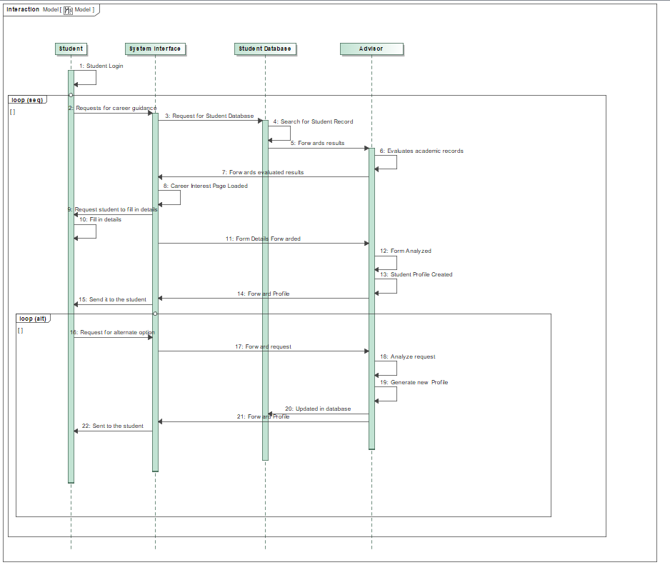

**4.2 Sequence Diagram for Career Advice Report**

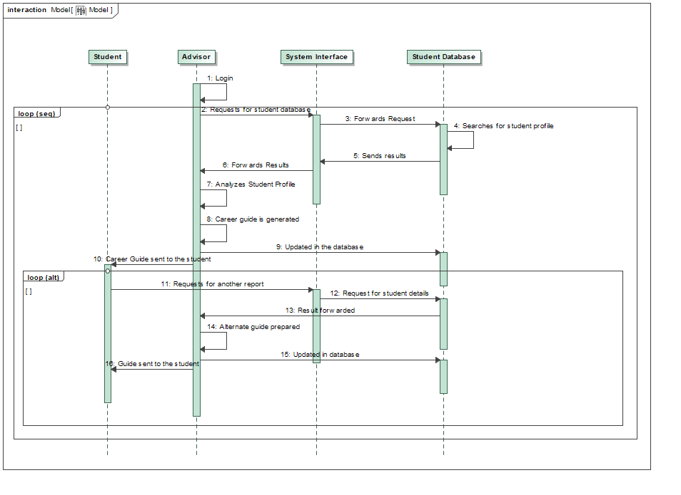

BCA

|  |  |  |
| --- | --- | --- |
|  | **Service name** | **Scope** |
| 1 | Request Career guidance() | Launch form to apply for career guidance. |
| 2 | Evaluate Academic Report() | Process academic details.. |
| 3. | Load Career Interest Form() | Update student’s career preference. |

|  |  |  |
| --- | --- | --- |
|  | **Responsibility name** | **Scope** |
| 1 | Generate Career guide() | Advisor generates a career guide |
| 2 | Analyze Student Profile() | Validate the academic record. |

ACA

|  |  |  |
| --- | --- | --- |
|  | **Service name** | **Scope** |
| 1 | Request Another Report() | Student requests to review the student report. |
| 2 | Prepare Alternate Guide() | Generate alternate career guide reports. |

**Sequence Diagram for Requesting for Admission**

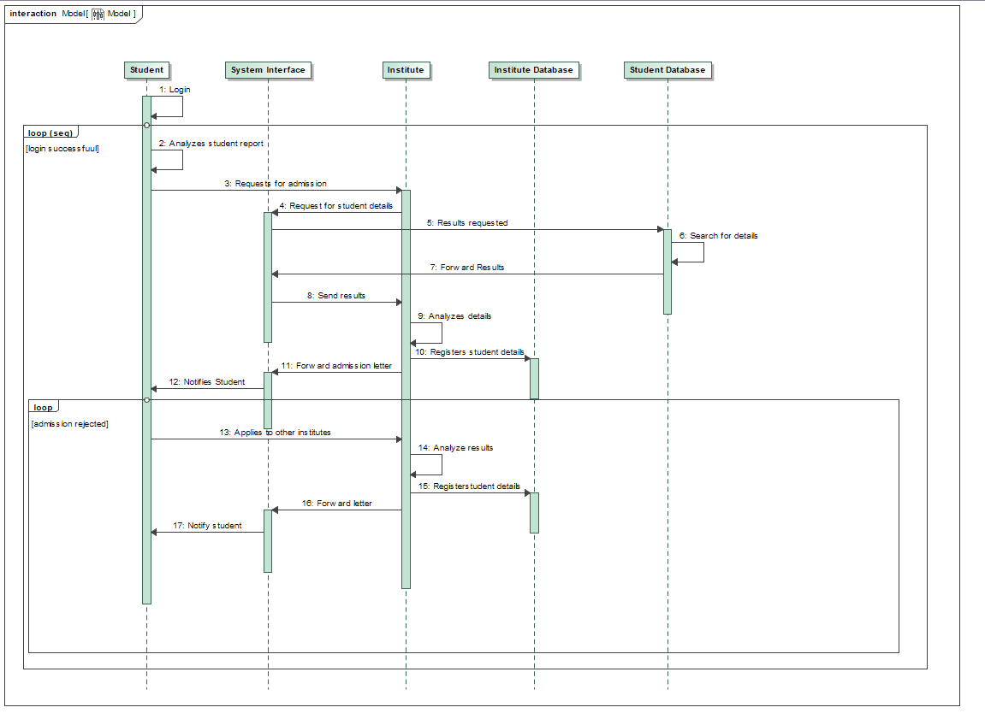

BCA

|  |  |  |
| --- | --- | --- |
|  | **Service name** | **Scope** |
| 1 | Student login() | Student logs in. |
| 2 | Analyse student report() | Process academic details.. |
| 3. | Request Admission() | Student applies to the institute. |

|  |  |  |
| --- | --- | --- |
|  | **Responsibility name** | **Scope** |
| 1 | Forward Admission letter() | Institute accepts the admission letter |
| 2 | Notify student() | Student acknowledges the admission. |

ACA

|  |  |  |
| --- | --- | --- |
|  | **Service name** | **Scope** |
| 1 | Apply to another institute() | Student applies to another institute. |
| 2 | Analyse report() | Generate alternate detailed institute list. |

***Statechart Diagrams***

***Assignment 6 – SDP LAB (CS3036)***

***Personal Counselling System***

Department of Computer Engineering

**BRACT’S Vishwakarma Institute Technology**

***PUNE – 411 037***



*Prepared by:*

|  |  |  |  |
| --- | --- | --- | --- |
| **Name** | **Division** | **Roll Number** | **GR Number** |
| Riya Mate | T.Y. D | 8 | 1710954 |
| Neha Khare | T.Y. D | 18 | 1710176 |
| Aditi Patil | T.Y. D | 28 | 1710383 |
| Akshay Patil | T.Y. D | 29 | 1710456 |

*Approved by:*

|  |  |  |
| --- | --- | --- |
| ***Name*** | ***Signature*** | ***Date*** |
| *Prof. Mahesh Dube* |  | *30 Sept 2016* |

**TABLE OF CONTENTS**

|  |  |
| --- | --- |
| **TITLE** | **PAGE** |
| 1. **Statechart Diagrams** | **94** |
| 1.1.1 Create Student Profile | **95** |
| 1.1.2 Authenticate Student Details | **96** |
| 1.2.1 Create Institute Profile | **97** |
| 1.2.2 Authenticate Institute Details | **98** |
| 1.3 Modify Student Details | **99** |
| 1.4.1 Add Academic Record | **100** |
| 1.4.2 Edit Academic Record | **101** |
| 1.5. Process Academic Record | **102** |
| 1.6. Provide Counselling | **103** |
| 1.7. Generate Report | **104** |
| 1.8. Online Application | **105** |

|  |
| --- |
| 1. ***Statechart Diagrams for “Personal Counselling System”*** |

This section describes the various statechart diagrams for Student Personnel Counselling System in detail.

|  |
| --- |
| ***1.1.1 - State Diagram - Create Student Profile*** |

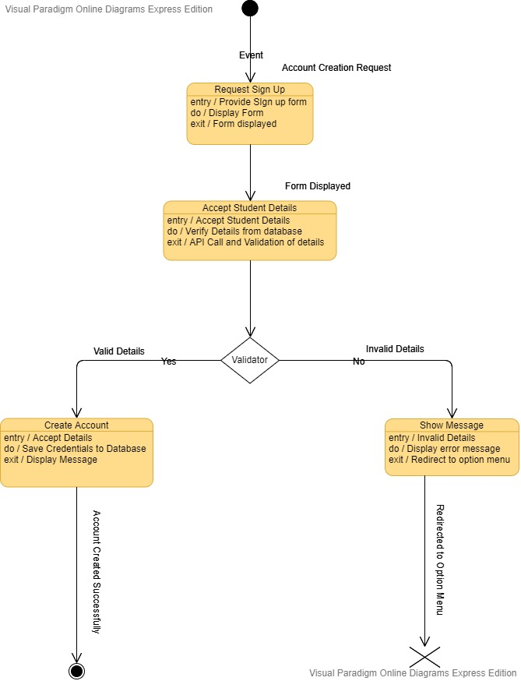

|  |
| --- |
| ***1.1.2. State Diagram - Authenticate Student Details*** |

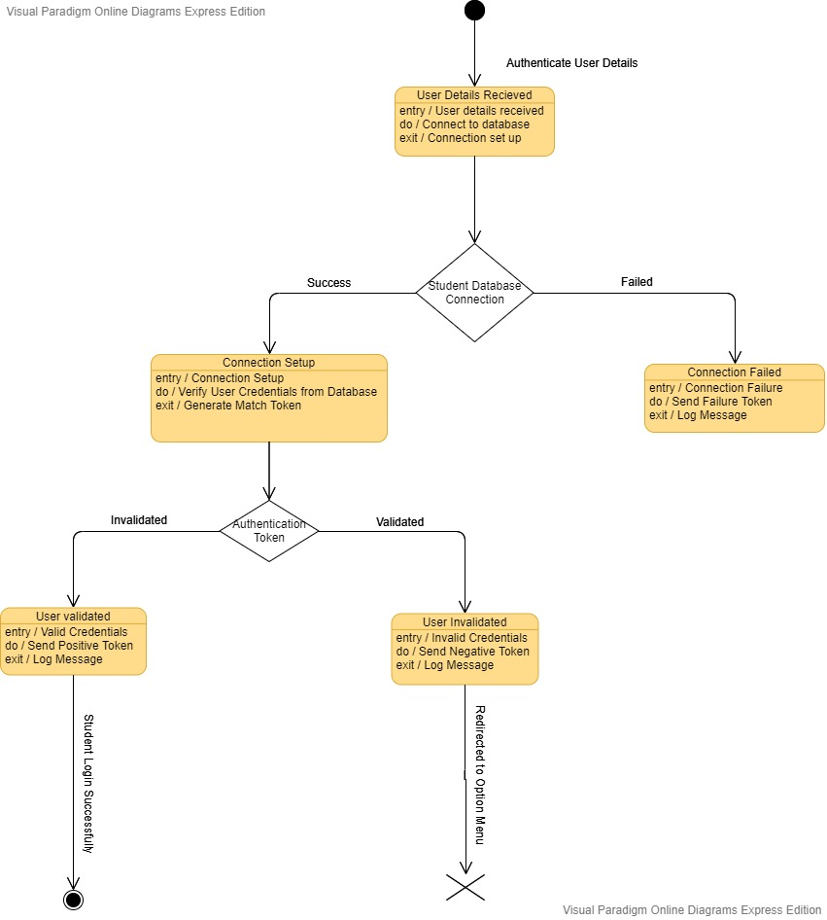

|  |
| --- |
| ***1.2.1 State Diagram - Create Institute Profile*** |

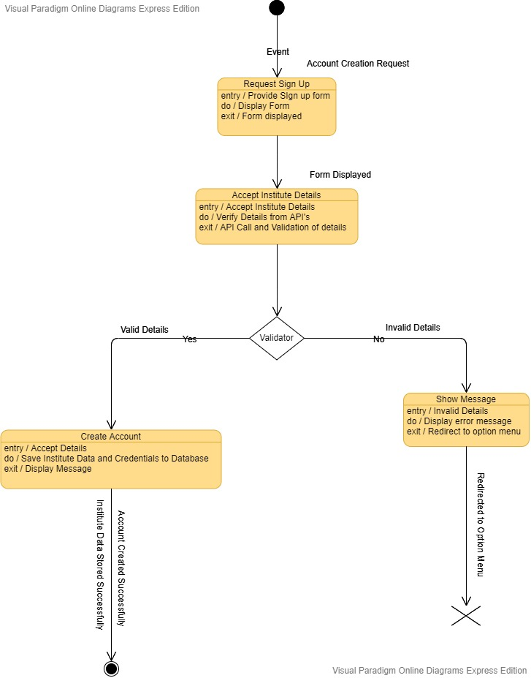

|  |
| --- |
| ***1.2.2 State Diagram - Authenticate Institute Details*** |

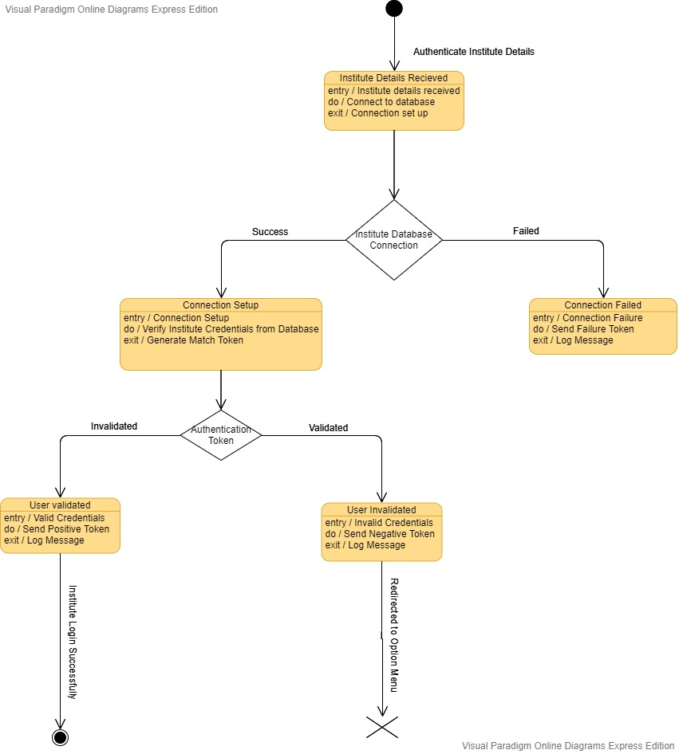

|  |
| --- |
| ***1.3 State Diagram - Modify Student Details*** |

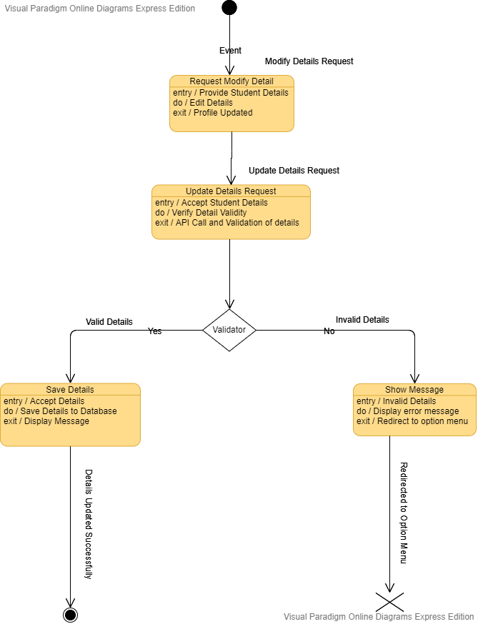

|  |
| --- |
| ***1.4.1 State Diagram - Add Academic Record*** |

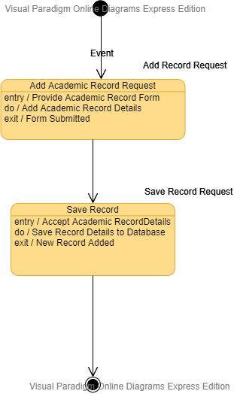

|  |
| --- |
| ***1.4.2 State Diagram - Edit Academic Record*** |

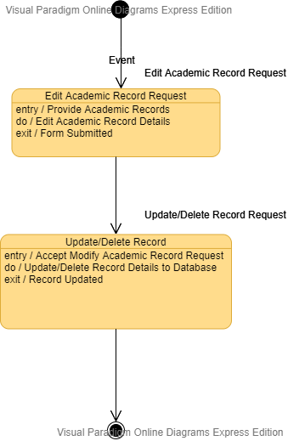

|  |
| --- |
| ***1.5 State Diagram - Process Academic Record*** |

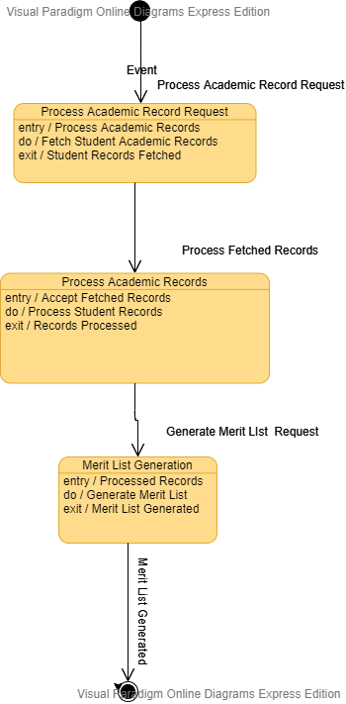

|  |
| --- |
| ***1.6 State Diagram - Provide Counselling*** |

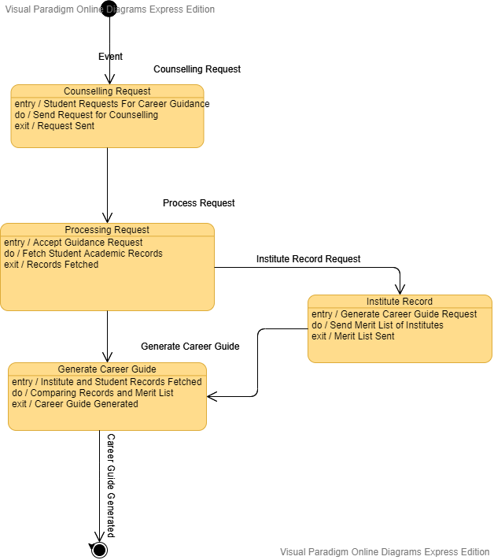

|  |
| --- |
| ***1.7 State Diagram - Generate Report*** |

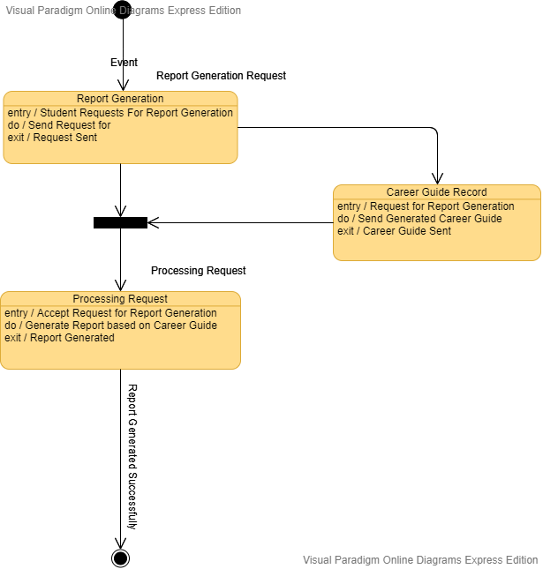

|  |
| --- |
| ***1.8 State Diagram - Online Application*** |

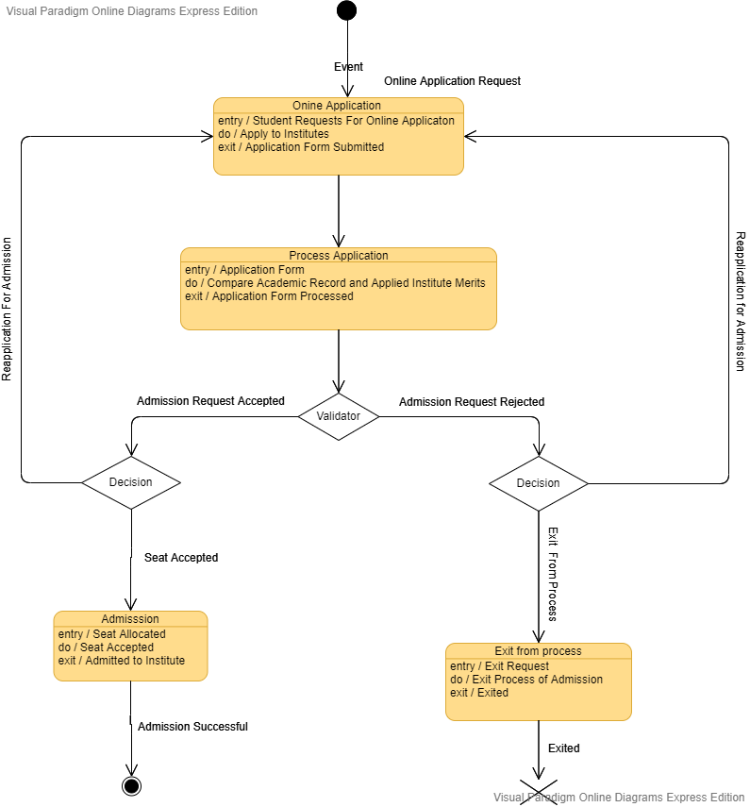

***Activity Diagrams***

***Assignment 7– SDP LAB (CS3036)***

***Personal Counselling System***

Department of Computer Engineering

**BRACT’S Vishwakarma Institute Technology**

***PUNE – 411 037***



*Prepared by:*

*Prepared by:*

|  |  |  |  |
| --- | --- | --- | --- |
| **Name** | **Division** | **Roll Number** | **GR Number** |
| Riya Mate | T.Y. D | 8 | 1710954 |
| Neha Khare | T.Y. D | 18 | 1710176 |
| Aditi Patil | T.Y. D | 28 | 1710383 |
| Akshay Patil | T.Y. D | 29 | 1710456 |

*Approved by:*

|  |  |  |
| --- | --- | --- |
| ***Name*** | ***Signature*** | ***Date*** |
| *Prof. Mahesh Dube* |  | *30th Mar 2020* |

***Table of Contents***

**1.****Introduction109**

**2.****How & where of Activity Diagram109**

**2.1.** **How to draw Activity Diagrams? 109**

**2.2.** **Where to use Activity Diagrams? 110**

**3.****Identifying components of Activity Diagram110**

**3.1.** **Activity 110**

**3.2.** **Activity Parameters 111**

**3.3.** **Activity Partition 111**

**3.4.** **Activity Edge 112**

[**4.****ACTIVITY Diagrams for “Personal Counselling System”**](https://docs.google.com/document/d/15FlVxIxO3TexmYeYGaNLml5-OlyAeBUr/edit#heading=h.4f1mdlm)**113**

[**4.1 ACTIVITY diagram 1.1 - Student Login**](https://docs.google.com/document/d/15FlVxIxO3TexmYeYGaNLml5-OlyAeBUr/edit#heading=h.2u6wntf) **113**

[**4.1.1 ACTIVITY diagram 1.2 - Validate Student Login**](https://docs.google.com/document/d/15FlVxIxO3TexmYeYGaNLml5-OlyAeBUr/edit#heading=h.19c6y18) **114**

[**4.1.2 ACTIVITY diagram 2.1 - Institute Login**](https://docs.google.com/document/d/15FlVxIxO3TexmYeYGaNLml5-OlyAeBUr/edit#heading=h.434ayfz) **115**

[**4.2 ACTIVITY diagram 2.2 – Fetch Institute Details**](https://docs.google.com/document/d/15FlVxIxO3TexmYeYGaNLml5-OlyAeBUr/edit#heading=h.3tbugp1) **116**

[**4.2.1**](https://docs.google.com/document/d/15FlVxIxO3TexmYeYGaNLml5-OlyAeBUr/edit#heading=h.28h4qwu) [**ACTIVITY diagram 3.1 –**](https://docs.google.com/document/d/15FlVxIxO3TexmYeYGaNLml5-OlyAeBUr/edit#heading=h.3tbugp1) **Providing of Academic Records 117**

[**4.2.2 ACTIVITY diagram 3.2 - Merit List Generation 1**](https://docs.google.com/document/d/15FlVxIxO3TexmYeYGaNLml5-OlyAeBUr/edit#heading=h.nmf14n)**18**

[**4.3. ACTIVITY diagram 4.1 – Analysis by advisor**](https://docs.google.com/document/d/15FlVxIxO3TexmYeYGaNLml5-OlyAeBUr/edit#heading=h.37m2jsg) **119**

[**4.3.1 ACTIVITY diagram 5.1 - Report Generation**](https://docs.google.com/document/d/15FlVxIxO3TexmYeYGaNLml5-OlyAeBUr/edit#heading=h.1mrcu09) **120**

# ***Introduction***

Activity diagrams are graphical representations of [workflows](http://en.wikipedia.org/wiki/Workflow) of stepwise activities and actions with support for choice, iteration and concurrency. In the [Unified Modeling Language](http://en.wikipedia.org/wiki/Unified_Modeling_Language), activity diagrams are intended to model both computational and organizational processes (i.e. workflows). Activity diagrams show the overall flow of control.

Activity diagrams are constructed from a limited number of shapes, connected with arrows. The most important shape types:

* Rounded rectangles represent actions
* Diamonds represent decisions
* Bars represent the start (split) or end (join) of concurrent activities
* A black circle represents the start (initial state) of the workflow
* An encircled black circle represents the end (final state)

The basic purposes of activity diagrams is to capture the dynamic behavior of the system. Other sequence diagrams are used to show the message flow from one object to another but activity diagram is used to show message flow from one activity to another.

Activity is a particular operation of the system. Activity diagrams are not only used for visualizing dynamic nature of a system but they are also used to construct the executable system by using forward and reverse engineering techniques. The only missing thing in activity diagram is the message part.

# ***How & where of Activity Diagram***

## ***How to draw Activity Diagrams?***

Activity diagrams are mainly used as a flow chart consists of activities performed by the system. But activity diagram is not exactly a flow chart as they have some additional capabilities. These additional capabilities include branching, parallel flow, swim lane etc.

Before drawing an activity diagram, we must have a clear understanding about the elements used in activity diagram. The main element of an activity diagram is the activity itself. An activity is a function performed by the system. After identifying the activities, we need to understand how they are associated with constraints and conditions.

So before drawing an activity diagram we should identify the following elements:

* Activities
* Association
* Conditions
* Constraints

Once the above-mentioned parameters are identified we need to make a mental layout of the entire flow. This mental layout is then transformed into an activity diagram.

## ***Where to use Activity Diagrams?***

The specific usage of the activity diagram is to model the control flow from one activity to another. This control flow does not include messages.

The activity diagram is suitable for modeling the activity flow of the system. An application can have multiple systems. Activity diagram also captures these systems and describes flow from one system to another. These systems can be databases, external queues or any other system.

The activity diagram is drawn from a very high level. So, it gives a high level view of a system. This high-level view is mainly for business users or any other person who is not a technical person.

This diagram is used to model the activities which are nothing but business requirements. Following are the main usages of activity diagram:

* Modeling workflow by using activities.
* Modeling business requirements.
* High level understanding of the system's functionalities.
* Investigate business requirements at a later stage.

# ***Identifying components of Activity Diagram***

## ***Activity***

**Activity** is a parameterized [behavior](http://www.uml-diagrams.org/common-behaviors.html#behavior) represented as coordinated flow of [actions](http://www.uml-diagrams.org/activity-diagrams-actions.html).

Activity contains **activity nodes** which could be:

* [action](http://www.uml-diagrams.org/activity-diagrams-actions.html)
* [object](http://www.uml-diagrams.org/activity-diagrams-objects.html)
* [control](http://www.uml-diagrams.org/activity-diagrams-controls.html)

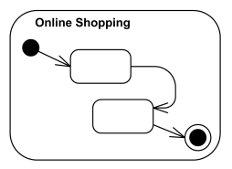

## ***Activity Parameters***

Activity parameters are displayed on the border and listed below the activity name as:  
   parameter-name: parameter-type.

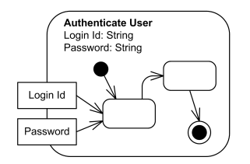

## ***Activity Partition***

An activity **partition** is **activity group** for actions that have some common characteristic.

Partitions often correspond to **organizational units** or **business actors** in a **business model**.

Partitions provide a constrained view on the behaviors invoked in activities. Constraints could be selected according to the type of the element that the partition represents. The following constraints are normative (standard) in UML 2.4:

* [classifier](http://www.uml-diagrams.org/classifier.html)
* [instance](http://www.uml-diagrams.org/uml-core.html#instance-core)
* [part](http://www.uml-diagrams.org/composite-structure-diagrams.html#part)
* [attribute](http://www.uml-diagrams.org/property.html#classifier-attribute) and value

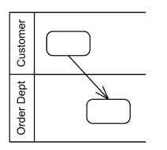

## ***Activity Edge***

**Activity Edge** is an abstract class for the directed connections along which **tokens** or **data objects** flow between **activity nodes**. It includes **control edges** and [object flow edges](http://www.uml-diagrams.org/activity-diagrams.html#object-flow-edge). The source and target of an edge must be in the same activity as the edge.

Activity edge is notated by an open arrowhead line connecting two activity nodes.

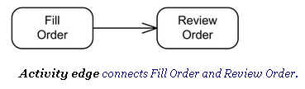

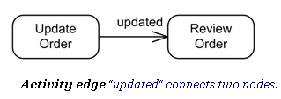

# ***Activity* *Diagrams for “Personal Counselling System”***

This section describes the various Activity diagrams for Online Bus Ticketing System in details.

## ***Activity diagram 1 - Student Login***

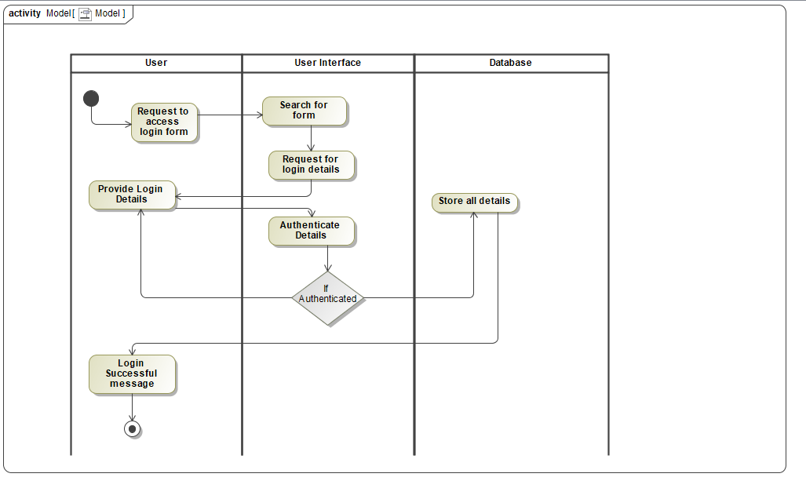

## ***Activity diagram 2 - Validate Student Login***

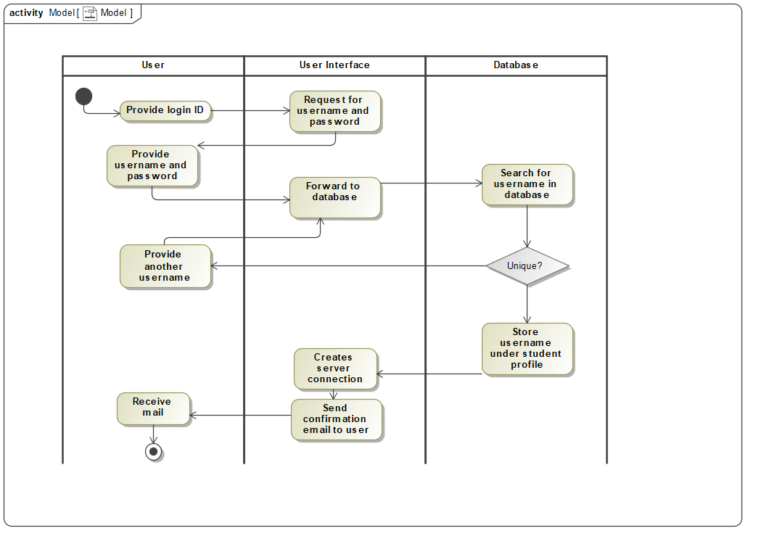

## ***Activity diagram 3 - Institute Login***

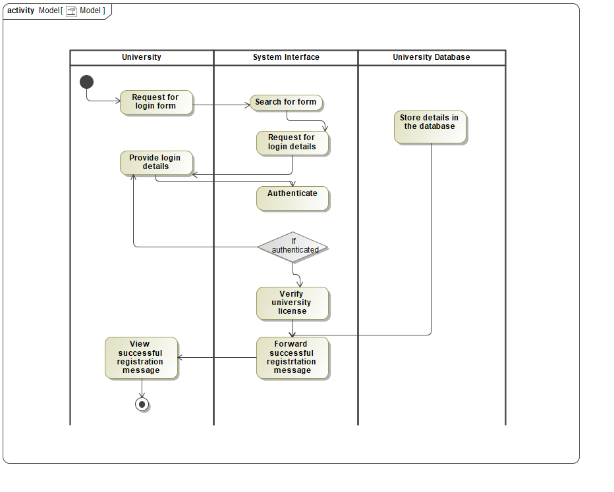

## ***Activity diagram 4 - Fetch Institute Details***

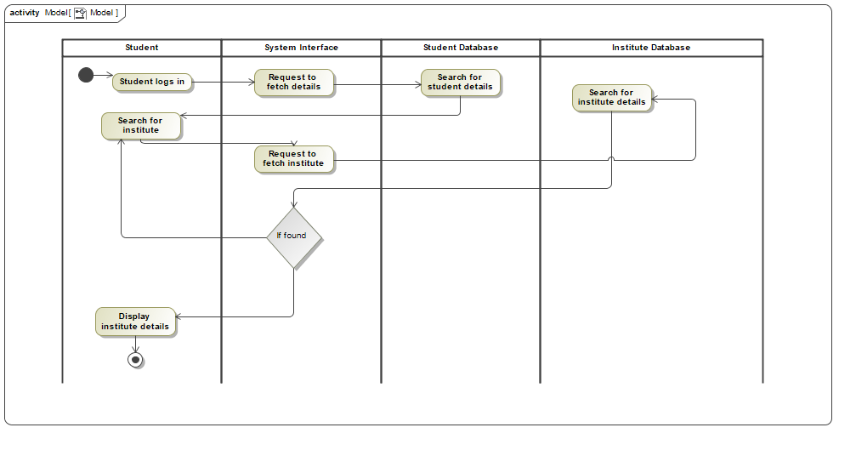

## ***Activity diagram 5 - Providing of Academic Records***

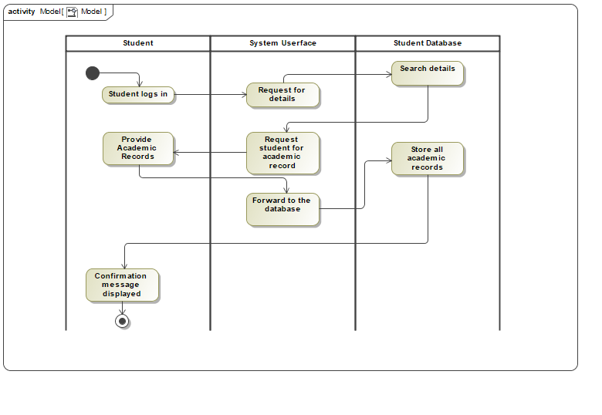

## ***Activity diagram 6 - Merit List Generation***

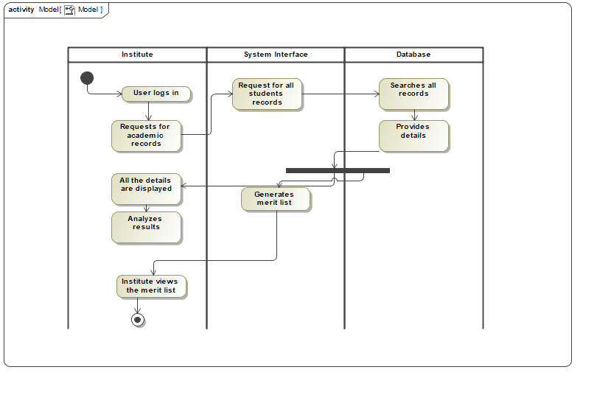

## ***Activity diagram 7 - Analysis by Advisor***

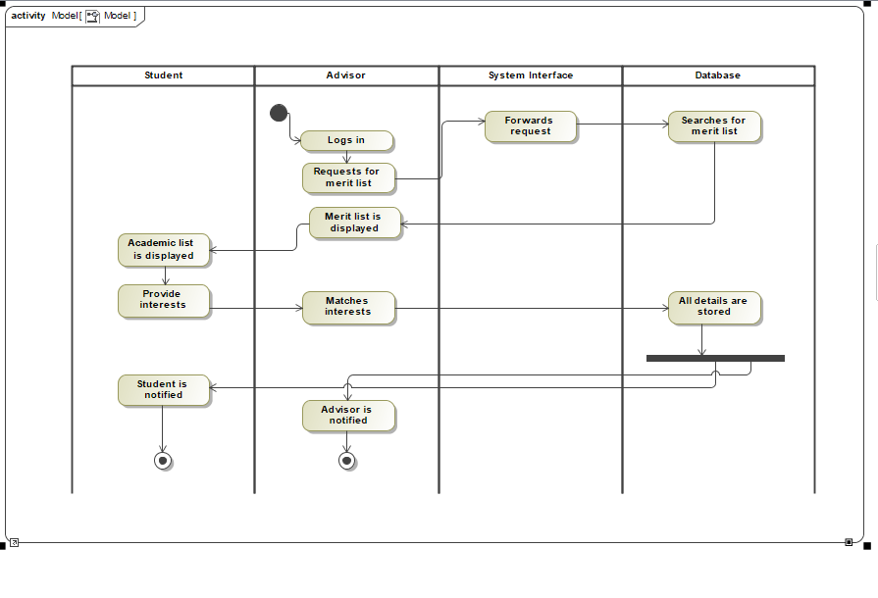

## ***Activity diagram 8 - Report Generation***

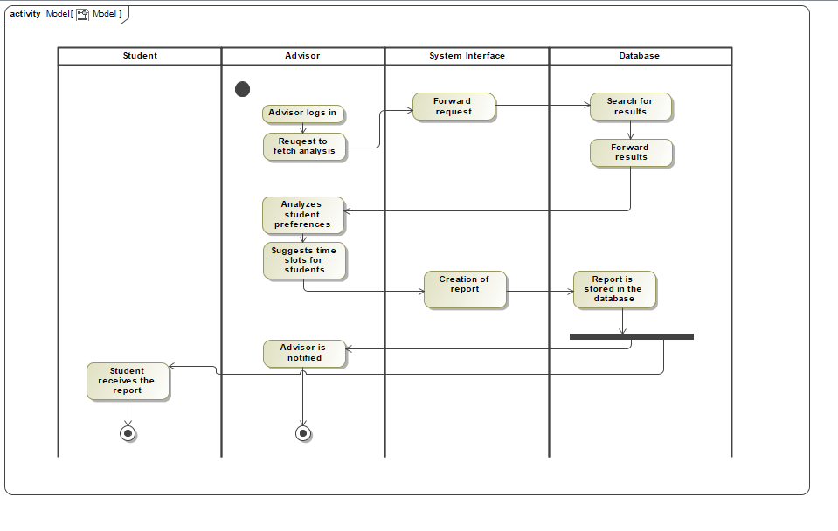

***Class Diagrams***

***Assignment 8– SDP LAB (CS3036)***

***Personal Counselling System***

Department of Computer Engineering

**BRACT’S Vishwakarma Institute Technology**

***PUNE – 411 037***



*Prepared by:*

|  |  |  |  |
| --- | --- | --- | --- |
| **Name** | **Division** | **Roll Number** | **GR Number** |
| Riya Mate | T.Y. D | 8 | 1710954 |
| Neha Khare | T.Y. D | 18 | 1710176 |
| Aditi Patil | T.Y. D | 28 | 1710383 |
| Akshay Patil | T.Y. D | 29 | 1710456 |

*Approved by:*

|  |  |  |
| --- | --- | --- |
| ***Name*** | ***Signature*** | ***Date*** |
| *Prof. Mahesh Dube* |  | *30th Mar 2020* |

***Table of Contents***

**1.****Introduction *111***

**1.1.Purpose 111**

**2.****How & Where of Class Diagram *112***

**2.1.How to draw Class Diagrams? 112**

**2.2.Where to use Class Diagrams? 112**

**3.****Identifying components of Class Diagram *113***

**3.1.Class 113**

**3.2.Class Features 113**

**3.3.Attribute Visibility 114**

**3.4.Abstract Class 114**

**4.****ClassDiagram for “Personal Counselling System” *115***

**5.****Class Responsibility Collaborator (CRC) Cards**

[**5.1.Class:**](https://docs.google.com/document/d/15FlVxIxO3TexmYeYGaNLml5-OlyAeBUr/edit#heading=h.3oy7u29) **Student 116**

**5.2.Class: Academic Record 117**

**5.3.Class: Institute 118**

**5.4.Class: Department 119**

**5.5.Class: Course 120**

**5.6.Class: Counselling 121**

**5.7.Class: Report 122**

**5.8.Class: Application 123**

# ***Introduction***

The class diagram is a static diagram. It represents the static view of an application. Class diagram is not only used for visualizing, describing and documenting different aspects of a system but also for constructing executable code of the software application.

The class diagram describes the attributes and operations of a class and also the constraints imposed on the system. The class diagrams are widely used in the modeling of object oriented systems because they are the only UML diagrams which can be mapped directly with object oriented languages.

The class diagram shows a collection of classes, interfaces, associations, collaborations and constraints. It is also known as a structural diagram.

## ***Purpose***

The purpose of the class diagram is to model the static view of an application. The class diagrams are the only diagrams which can be directly mapped with object oriented languages and thus widely used at the time of construction.

The UML diagrams like activity diagram, sequence diagram can only give the sequence flow of the application but class diagram is a bit different. So it is the most popular UML diagram in the coder community.

So the purpose of the class diagram can be summarized as:

* Analysis and design of the static view of an application.
* Describe responsibilities of a system.
* Base for component and deployment diagrams.
* Forward and reverse engineering.

# ***How & Where of Class Diagram***

## ***How to draw Class Diagrams?***

Class diagrams are the most popular UML diagrams used for construction of software applications. So it is very important to learn the drawing procedure of class diagram. Class diagrams have lot of properties to consider while drawing.

Class diagram is basically a graphical representation of the static view of the system and represents different aspects of the application. So a collection of class diagrams represent the whole system.

The following points should be remembered while drawing a class diagram:

* The name of the class diagram should be meaningful to describe the aspect of the system.
* Each element and their relationships should be identified in advance.
* Responsibility (attributes and methods) of each class should be clearly identified.
* For each class minimum number of properties should be specified. Because unnecessary properties will make the diagram complicated.
* Use notes when ever required to describe some aspect of the diagram. Because at the end of the drawing it should be understandable to the developer/coder.
* Finally, before making the final version, the diagram should be drawn on plain paper and rework as many times as possible to make it correct.

## ***Where to use Class Diagrams?***

Class diagram is a static diagram and it is used to model static view of a system. The static view describes the vocabulary of the system. Class diagram is also considered as the foundation for component and deployment diagrams. Class diagrams are not only used to visualize the static view of the system but they are also used to construct the executable code for forward and reverse engineering of any system.

Generally UML diagrams are not directly mapped with any object oriented programming languages but the class diagram is an exception. Class diagram clearly shows the mapping with object oriented languages like Java, C++ etc. So from practical experience, class diagram is generally used for construction purpose.

So in a brief, class diagrams are used for:

* Describing the static view of the system.
* Showing the collaboration among the elements of the static view.
* Describing the functionalities performed by the system.
* Construction of software applications using object oriented languages.

# ***Identifying components of Class Diagram***

## ***Class***

A **class** is a [classifier](http://www.uml-diagrams.org/classifier.html) which describes a set of objects that share the same [features](http://www.uml-diagrams.org/uml-core.html#feature), [constraints](http://www.uml-diagrams.org/constraint.html) & **semantics (meaning)**.

A class is shown as a solid-outline rectangle containing the class name, and optionally with compartments separated by horizontal lines containing features or other members of the classifier.

As class is the most widely used classifier, there is no need to add the "class" keyword in guillemets (double angle quotes) above the class name. Class name should be **centered** and in **bold** face, with the first letter of class name capitalized (if the character set supports upper case).

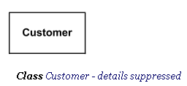

## ***Class Features***

[Features](http://www.uml-diagrams.org/uml-core.html#feature) of a class are attributes and operations.

When class is shown with three compartments, the middle compartment holds a list of attributes and the bottom compartment holds a list of operations. Attributes and operations should be left justified in plain face, with the first letter of the names in lower case.

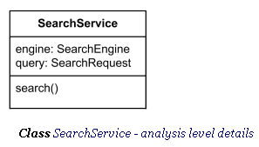

## ***Attribute Visibility***

Attributes or operations may be grouped by **visibility**. A visibility keyword or symbol in this case can be given once for multiple features with the same visibility.

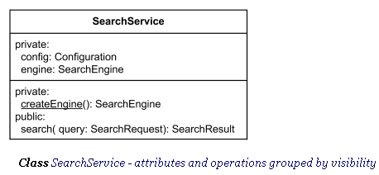

## ***Abstract Class***

**Abstract class** was defined in **UML 1.4.2** as class that can't be directly instantiated. Abstract class exists only for other classes to inherit from and to support reuse of the features declared by it. No object may be a direct instance of an abstract class, although an object may be an indirect instance of one through a subclass that is non-abstract.

The name of an **abstract class** is shown in **italics**.

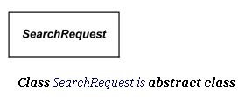

# ***4. Class* *Diagram for “Personal Counselling System”***

Following is the Class diagram for Personal Counselling System.

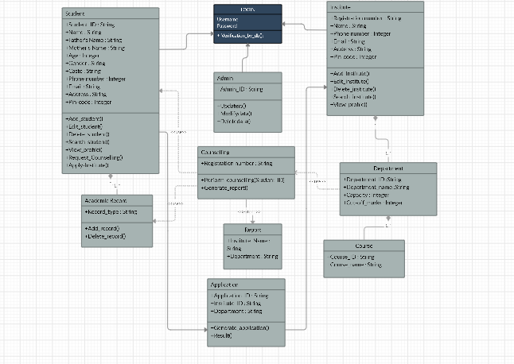

# ***5. Class Responsibility Collaborator (CRC) Cards***

## ***5.1. Class: Student***

|  |  |
| --- | --- |
| ***Class Name*** | ***Student*** |
| ***Class Type*** | *Control Object* |
| ***Characteristics*** | *Tangible* |
| ***Super class*** | *None* |
| ***Subclass*** | * ***Academic Record*** |
| ***Variables*** | * *Student_ID : String* * *Name : String* * *Father's Name : String* * *Mother's Name : String* * *Age : Integer* * *Gender : String* * *Caste : String* * *Phone number : Integer* * *Email : String* * *Address : String* * *Pin-code : Integer* |
| ***Services*** | * *Add_student()* * *Edit_student()* * *Delete_student()* * *Search_student()* * *View_profile()* * *Request_Counselling()* * *Apply-Institute()* |
| ***Responsibilities*** | ***Collaborators*** |
| *Initialize System()*  *Initialize Connection()*  *Register Student()*  *Get Student Data()*  *Process Data()* | *Student Database* |

## ***5.2. Class: Academic Record***

|  |  |
| --- | --- |
| ***Class Name*** | ***Academic Record*** |
| ***Class Type*** | *Control Object* |
| ***Characteristics*** | *Tangible* |
| ***Super class*** | ***Student*** |
| ***Subclass*** | ***None*** |
| ***Variables*** | * *Student_ID : String* * *Record_type : String* |
| ***Services*** | * *Add_record()* * *Delete_record()* |
| ***Responsibilities*** | ***Collaborators*** |
| *Add academic record()*  *Delete academic record()* | *Student Database*  *Academic Record Database* |

## ***5.3. Class: Institute***

|  |  |
| --- | --- |
| ***Class Name*** | ***Institute*** |
| ***Class Type*** | *Control Object* |
| ***Characteristics*** | *Tangible* |
| ***Super class*** | ***None*** |
| ***Subclass*** | * ***Department*** |
| ***Variables*** | * *Institute_ID : String* * *Name : String* * *Phone number : Integer* * *Email : String* * *Address : String* * *Pin-code : Integer* |
| ***Services*** | * *Add_institute()* * *Edit_institute()* * *Delete_institute()* * *Search_institute()* * *View_profile()* |
| ***Responsibilities*** | ***Collaborators*** |
| *Add Institute Data()*  *Update Institute Data()* | *Institute Database* |

## ***5.4. Class: Department***

|  |  |
| --- | --- |
| ***Class Name*** | ***Institute*** |
| ***Class Type*** | *Control Object* |
| ***Characteristics*** | *Tangible* |
| ***Super class*** | ***Institute*** |
| ***Subclass*** | * ***Course*** |
| ***Variables*** | * *Department_ID :String* * *Department_name :String* * *Capacity : Integer* * *Cut-off_marks : Integer* |
| ***Responsibilities*** | ***Collaborators*** |
| *Store Department Data()*  *Department Seats()* | *Institute Database* |

## ***5.5. Class: Course***

|  |  |
| --- | --- |
| ***Class Name*** | ***Course*** |
| ***Class Type*** | *Control Object* |
| ***Characteristics*** | *Tangible* |
| ***Super class*** | ***Department*** |
| ***Subclass*** | ***None*** |
| ***Variables*** | * *Course_ID : String* * *Course_name : String* |
| ***Responsibilities*** | ***Collaborators*** |
| *Course Data()*  *Course Duration()* | *Institute Database* |

## ***5.6. Class: Counselling***

|  |  |
| --- | --- |
| ***Class Name*** | ***Institute*** |
| ***Class Type*** | *Control Object* |
| ***Characteristics*** | *Tangible* |
| ***Super class*** | ***None*** |
| ***Subclass*** | ***None*** |
| ***Variables*** | * *Counselling ID* |
| ***Services*** | * *Perform_counselling()* * *Generate_report()* |
| ***Responsibilities*** | ***Collaborators*** |
| *Get Student Data()*  *Get Academic Records()*  *Get Institute Data()*  *Get Department Data()*  *Get Department Seats()*  *Get Department Cutoff()*  *Compare Academic Record()*  *Generate Counselling Record()*  *Send Report to Student()* | *Student Database*  *Academic Record Database*  *Institute Database* |

## ***5.7. Class: Report***

|  |  |
| --- | --- |
| ***Class Name*** | ***Report*** |
| ***Class Type*** | *Control Object* |
| ***Characteristics*** | *Tangible* |
| ***Super class*** | ***Counselling*** |
| ***Subclass*** | ***None*** |
| ***Variables*** | * *Institute ID* * *Department ID* * *Course ID* |
| ***Responsibilities*** | ***Collaborators*** |
| *Display Institute()*  *Display Department Data()*  *Display Courses Data()* | *Student Database*  *Academic Record Database*  *Institute Database* |

## ***5.8. Class: Application***

|  |  |
| --- | --- |
| ***Class Name*** | ***Report*** |
| ***Class Type*** | *Control Object* |
| ***Characteristics*** | *Tangible* |
| ***Super class*** | ***Counselling*** |
| ***Subclass*** | ***None*** |
| ***Variables*** | *Student_ID*  *Institute_ID* |
| ***Services*** | *Verify_student_records()*  *Grant_application()* |
| ***Responsibilities*** | ***Collaborators*** |
| *Verify academic records()*  *Generate application result()*  *Send report to student()* | *Student Database*  *Institute Database* |

*Component Diagram*

***Assignment 8– SDP LAB (CS3036)***

***Personal Counselling System***

Department of Computer Engineering

**BRACT’S Vishwakarma Institute Technology**

***PUNE – 411 037***



*Prepared by:*

|  |  |  |  |
| --- | --- | --- | --- |
| **Name** | **Division** | **Roll Number** | **GR Number** |
| Riya Mate | T.Y. D | 8 | 1710954 |
| Neha Khare | T.Y. D | 18 | 1710176 |
| Aditi Patil | T.Y. D | 28 | 1710383 |
| Akshay Patil | T.Y. D | 29 | 1710456 |

*Approved by:*

|  |  |  |
| --- | --- | --- |
| ***Name*** | ***Signature*** | ***Date*** |
| *Prof. Mahesh Dube* |  | *30 Sept 2016* |

# ***Introduction***

Component diagrams are different in terms of nature and behavior. Component diagrams are used to model physical aspects of a system.

Now the question is what are these physical aspects? Physical aspects are the elements like executables, libraries, files, documents etc which reside in a node.

So, component diagrams are used to visualize the organization and relationships among components in a system. These diagrams are also used to make executable systems.

## ***Purpose***

Component diagram is a special kind of diagram in UML. The purpose is also different from all other diagrams discussed so far. It does not describe the functionality of the system but it describes the components used to make those functionalities.

So from that point of view, component diagrams are used to visualize the physical components in a system. These components are libraries, packages, files etc.

Component diagrams can also be described as a static implementation view of a system. Static implementation represents the organization of the components at a particular moment.

A single component diagram cannot represent the entire system but a collection of diagrams is used to represent the whole.

So, the purpose of the component diagram can be summarized as:

* Visualize the components of a system.
* Construct executables by using forward and reverse engineering.
* Describe the organization and relationships of the components.

# ***How & Where of Component Diagram***

## ***How to draw component Diagrams?***

Component diagrams are used to describe the physical artifacts of a system. This artifact includes files, executables, libraries etc.

So, the purpose of this diagram is different, Component diagrams are used during the implementation phase of an application. But it is prepared well in advance to visualize the implementation details.

Initially the system is designed using different UML diagrams and then when the artifacts are ready, component diagrams are used to get an idea of the implementation.

This diagram is very important because without it the application cannot be implemented efficiently. A well-prepared component diagram is also important for other aspects like application performance, maintenance etc.

So before drawing a component diagram the following artifacts are to be identified clearly:

* Files used in the system.
* Libraries and other artifacts relevant to the application.
* Relationships among the artifacts.

Now after identifying the artifacts the following points needs to be followed:

* Use a meaningful name to identify the component for which the diagram is to be drawn.
* Prepare a mental layout before producing using tools.
* Use notes for clarifying important points.

## ***Where to use component Diagrams?***

We have already described that component diagrams are used to visualize the static implementation view of a system. Component diagrams are special type of UML diagrams used for different purposes.

These diagrams show the physical components of a system. To clarify it, we can say that component diagrams describe the organization of the components in a system.

Organization can be further described as the location of the components in a system. These components are organized in a special way to meet the system requirements.

As we have already discussed those components are libraries, files, executables etc. Now before implementing the application these components are to be organized. This component organization is also designed separately as a part of project execution.

Component diagrams are very important from implementation perspective. So the implementation team of an application should have a proper knowledge of the component details.

Now the usage of component diagrams can be described as:

* Model the components of a system.
* Model database schema.
* Model executables of an application.
* Model system's source code.

# ***Identifying components of Class Diagram***

## ***Component***

A **component** is a [structured class](http://www.uml-diagrams.org/composite-structure-diagrams.html#structured-class) representing a modular part of a system with encapsulated content and whose [manifestation](http://www.uml-diagrams.org/deployment-diagrams.html#manifestation) is replaceable within its environment.

A component has its behavior defined in terms of [provided interfaces](http://www.uml-diagrams.org/component-diagrams.html#provided-interface) and [required interfaces](http://www.uml-diagrams.org/component-diagrams.html#required-interface) (potentially exposed via **ports**).

**Indirectly instantiated component** is defined at design time but does not exist as addressable object at execution time. Runtime behavior of the component and its ports is defined by the runtime behavior of classifiers or parts realizing it. Several standard stereotypes assume this attribute, e.g., [«specification»](http://www.uml-diagrams.org/component-diagrams.html#specification), [«focus»](http://www.uml-diagrams.org/class-diagrams.html#focus), [«subsystem»](http://www.uml-diagrams.org/component-diagrams.html#subsystem).

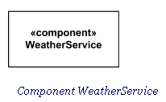

## ***Provided Interface***

A **provided interface** is the one that is either

* [realized](http://www.uml-diagrams.org/abstraction.html#interface-realization) directly by the component itself, or
* [realized](http://www.uml-diagrams.org/abstraction.html#interface-realization) by one of the classifiers realizing component, or
* is provided by a public port of the component.

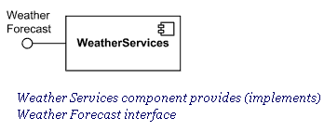

## ***Required Interface***

A **required interface** is either

* designated by usage dependency from the component itself, or
* designated by usage dependency from one of the classifiers realizing component, or
* is required by a public port of the component.

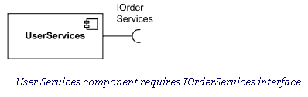

## ***Connector***

**Connector** in components extends [connector](http://www.uml-diagrams.org/composite-structure-diagrams.html#connector) from [internal structures](http://www.uml-diagrams.org/composite-structure-diagrams.html#internal-structure-diagrams). It specifies a **link** that enables communication between two or more instances. Connector was extended in the components to include **contracts** and specific notation.

Connector linking components could be either:

* [delegation connector](http://www.uml-diagrams.org/component-diagrams.html#delegation-connector), or
* [assembly connector](http://www.uml-diagrams.org/component-diagrams.html#assembly-connector).

Kind of connector attribute is derived: a connector with one or more ends connected to a port that is not on a part and that is not a behavior port is a delegation; otherwise it is an assembly. Connector's **contract** is set of behaviors that specify the valid interaction patterns across the connector.

## ***External View of Component***

A component has an **external view** or **"black-box"** view by means of interface symbols sticking out of the component box exposing its publicly visible properties and operations.

Optionally, a behavior such as a protocol state machine may be attached to an interface, port, and to the component itself, to define the external view more precisely by making dynamic constraints in the sequence of operation calls explicit. Other behaviors may also be associated with interfaces or connectors to define the "contract" between participants in a collaboration (e.g., in terms of use case, activity, or interaction specifications).

Alternatively, the interfaces and/or individual operations and attributes can be listed in the compartments of a component box (for scalability, tools may offer a way of listing and abbreviating component properties and behavior).

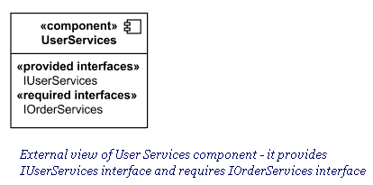

# ***Component Diagram Terminology explained with sample***

Following diagram illustrates all the terminology used in UML Component diagram.

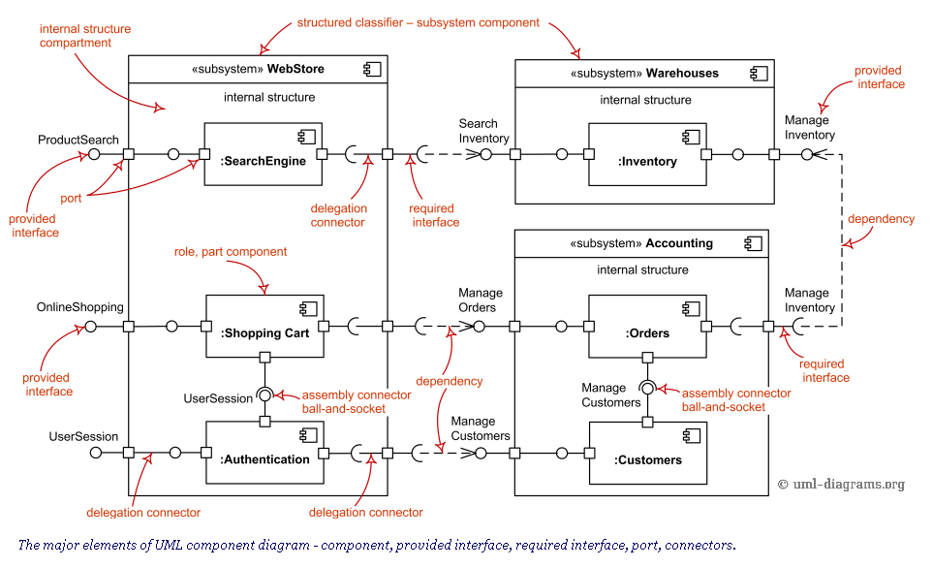

# ***Component* *Diagram for Personal Counseling System***

## ***5.1. Component diagram***

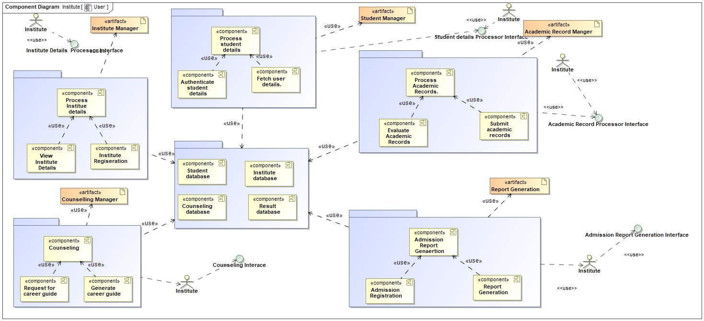

## ***5.2. Component details:***

|  |  |
| --- | --- |
| **Component** | Student Profile |
| **Kind of Component** | Module |
| **Responsibilities** | Create student profile. |
| **Processing** | 1. Display student registration form. 2. Accept, validate and store student information.   . |
| **Reference** | None |
| **Constraints** | Only the student can use this functionality. |
| **Composition** | Store child information in the student database. |
| **Resources** | Student Database |
| **Interactions** | Academic Record  Counselling  Application |
| **Interface/Exports** | None |

## ***5.2.1Procedure Definition Language (Pseudo-code):***

STUDENT Requests to Register a New Student_Profile

SYSTEM Accepts Student Information

Show Main Menu of application

Show “Register New Student” Button

IF Student Clicks “Register New Child” button

Accept Student Details

IF Account Information is validated correctly

Display Student Information

Goto Login Form

END IF

ELSE IF Student Registration Done

` Show Main Menu of application

END IF

Terminate

## ***.2. Component details: Institute Profile***

|  |  |
| --- | --- |
| **Component** | Institute Profile |
| **Kind of Component** | Module |
| **Responsibilities** | Create institute profile. |
| **Processing** | 1. Display institute registration form. 2. Accept, validate and store institute information. 3. Display institute information for student to view.   . |
| **Reference** | None |
| **Constraints** | Only the institute can use this functionality. |
| **Composition** | Store institute information in the institute database. |
| **Resources** | Institute Database |
| **Interactions** | Academic Record  Application |
| **Interface/Exports** | Institute Application |

## ***5.2.1Procedure Definition Language (Pseudo-code):***

INSTITUTE Requests to Register a New Student_Profile

SYSTEM Accepts Student Information

Show Main Menu of application

Show “Register New Institute” Button

IF Student Clicks “Register New Institute” button

Accept Institute Details

IF Account Information is validated correctly

Display Institute Information

Goto Login Form

END IF

ELSE IF Institute Registration Done

` Show Main Menu of application

END IF

Accept Applications from students

IF Application Granted

Send Acceptance Report to Student

END IF

ELSE

Send Denial Report to Student

END IF

Terminate

## ***5.5. Component details: Generate Admission Report***

|  |  |
| --- | --- |
| **Component Name** | Formulate Student_Academic_Record |
| **Kind of Component** | Sub – module |
| **Responsibilities** | Generate Student admission report. |
| **Processing** | 1. Generate student admission report |
| **Reference** | None |
| **Constraints** | Students with a registered profile only can use this functionality. |
| **Composition** | Construct student admission report |
| **Resources** | Student profile db. |
| **Interactions** | Provide Admission_Assistance |
| **Interface/Exports** | None. |

**Procedure Definition Language: Generate Admission_Report**

STUDENT Requests to Generate Admission report

SYSTEM Accepts the Request

Show Main menu of application

Display “Student Admission Application” button

IF Student selects representation button

Fetch various institute profiles with available fields

IF Student profile accepted

Process Student profile

Fetch previous academic records of Student

Display comparison parameters

IF Institute selects parameters

Formulate parameters

Generate admission report

Display Admission report

END IF

ELSE

Show Error “Student record not accepted”

END IF

ELSE

Goto main menu

END IF

Terminate

**Procedure Definition Language:Counseling**

Student Requests for Career Guidance

SYSTEM Accepts the Request

Show Main menu of application

Display “Ask Advice” button

IF Advisor selects evaluate button

Fetch various student profiles with academic records

IF student profile exist

Process student profiles

Fetch previous records of multiple profiles

Display comparison parameters

IF Advisor selects parameters

Formulate parameters

Generate evaluation report

Display merit list

END IF

ELSE

Show Error “Student Info not correct”

END IF

ELSE

Goto main menu

END IF

Terminate

*Deployment Diagram*

***Assignment 9– SDP LAB (CS3036)***

***Personal Counselling System***

Department of Computer Engineering

**BRACT’S Vishwakarma Institute Technology**

***PUNE – 411 037***



*Prepared by:*

|  |  |  |  |
| --- | --- | --- | --- |
| **Name** | **Division** | **Roll Number** | **GR Number** |
| Riya Mate | T.Y. D | 8 | 1710954 |
| Neha Khare | T.Y. D | 18 | 1710176 |
| Aditi Patil | T.Y. D | 28 | 1710383 |
| Akshay Patil | T.Y. D | 29 | 1710456 |

*Approved by:*

|  |  |  |
| --- | --- | --- |
| ***Name*** | ***Signature*** | ***Date*** |
| *Prof. Mahesh Dube* |  | *30 Sept 2016* |

***Table of Contents***

**1.** **Introduction 109**

**1.1.** **Purpose 109**

**2.** **How & Where of Deployment Diagram 110**

**2.1.** **How to draw Deployment Diagrams? 111**

**2.2.** **Where to use Deployment Diagrams? 112**

**3.** **Identifying components of Deployment Diagram 112**

**3.1.** **Artifacts 112**

**3.2.** **Deployment Target 112**

**3.3.** **Common types of deployment diagrams 112**

**4.** **Deployment Diagram Terminology explained with sample 113**

**5.** **Deployment Diagram for “Personal Counseling System” 114**

[**5.1. Deployment diagram**](https://docs.google.com/document/d/15FlVxIxO3TexmYeYGaNLml5-OlyAeBUr/edit#heading=h.3hej1je) **114**

**5.2. Component description:Process User Details 114**

**5.3. Component description: Process Institute details 114**

**5.4. Component description: Process Academic Records 115**

**5.5. Component description: Counseling 115**

**5.6. Component description: Admission Report generation 116**

# ***Introduction***

Deployment diagrams are used to visualize the topology of the physical components of a system where the software components are deployed.

So, deployment diagrams are used to describe the static deployment view of a system. Deployment diagrams consist of nodes and their relationships.

**Deployment diagram** is a [structure diagram](http://www.uml-diagrams.org/uml-25-diagrams.html#structure-diagram) which shows architecture of the system as deployment (distribution) of software artifacts to deployment targets.

## ***Purpose***

The name Deployment itself describes the purpose of the diagram. Deployment diagrams are used for describing the hardware components where software components are deployed.

Component diagrams and deployment diagrams are closely related. Component diagrams are used to describe the components and deployment diagrams shows how they are deployed in hardware.

UML is mainly designed to focus on software artifacts of a system. But these two diagrams are special diagrams used to focus on software components and hardware components.

So, most of the UML diagrams are used to handle logical components but deployment diagrams are made to focus on hardware topology of a system. Deployment diagrams are used by the system engineers.

The purpose of deployment diagrams can be described as:

* Visualize hardware topology of a system.
* Describe the hardware components used to deploy software components.
* Describe runtime processing nodes.

# ***How & Where of Deployment Diagram***

## ***How to draw Deployment Diagrams?***

Deployment diagram represents the deployment view of a system. It is related to the component diagram. Because the components are deployed using the deployment diagrams.

A deployment diagram consists of nodes. Nodes are nothing but physical hardware used to deploy the application. Deployment diagrams are useful for system engineers. An efficient deployment diagram is very important because it controls the following parameters

* Performance
* Scalability
* Maintainability
* Portability

So before drawing a deployment diagram the following artifacts should be identified:

* Nodes
* Relationships among nodes

## ***Where to use Deployment Diagrams?***

Deployment diagrams are mainly used by system engineers. These diagrams are used to describe the physical components (hardware), their distribution and association.

To clarify it in detail we can visualize deployment diagrams as the hardware components/nodes on which software components reside. Software applications are developed to model complex business processes. Only efficient software applications are not sufficient to meet business requirements. Business requirements can be described as to support increasing number of users, quick response time etc.

To meet these types of requirements hardware components should be designed efficiently and in a cost, effective way. Now a day's software applications are very complex in nature. Software applications can be stand alone, web based, distributed, mainframe based and many more. So, it is very important to design the hardware components efficiently.

So, the usage of deployment diagrams can be described as follows:

* To model the hardware topology of a system.
* To model embedded systems.
* To model hardware details for a client/server system.
* To model hardware details of a distributed application.
* Forward and reverse engineering.

# ***Identifying components of Deployment Diagram***

## ***Artifacts***

[Artifacts](http://www.uml-diagrams.org/deployment-diagrams.html#artifact) represent concrete elements in the physical world that are the result of a development process. Examples of artifacts are executable files, libraries, archives, database schemas, configuration files, etc.

## ***Deployment Target***

[Deployment target](http://www.uml-diagrams.org/deployment-diagrams.html#deployment-target) is usually represented by a [node](http://www.uml-diagrams.org/deployment-diagrams.html#node) which is either hardware device or some software execution environment. Nodes could be connected through [communication paths](http://www.uml-diagrams.org/deployment-diagrams.html#communication-path) to create networked systems of arbitrary complexity.

Note, that [components](http://www.uml-diagrams.org/component-diagrams.html#component) were directly deployed to nodes in UML 1.x deployment diagrams. In UML 2.x [artifacts](http://www.uml-diagrams.org/deployment-diagrams.html#artifact) are deployed to nodes, and artifacts could [manifest](http://www.uml-diagrams.org/deployment-diagrams.html#manifestation) (implement) components. Components are deployed to nodes indirectly through artifacts.

## ***Common types of deployment diagrams***

Some common types of deployment diagrams are:

* [Implementation (manifestation) of components by artifacts](http://www.uml-diagrams.org/deployment-diagrams-overview.html#deployment-manifestation-artifacts),
* [Specification level deployment diagram](http://www.uml-diagrams.org/deployment-diagrams-overview.html#specification-level-deployment),
* [Instance level deployment diagram](http://www.uml-diagrams.org/deployment-diagrams-overview.html#instance-level-deployment),
* [Network architecture of the system](http://www.uml-diagrams.org/network-architecture-diagrams.html).

# ***Deployment Diagram Terminology explained with sample***

Following diagram illustrates all the terminology used in UML Deployment Diagram.

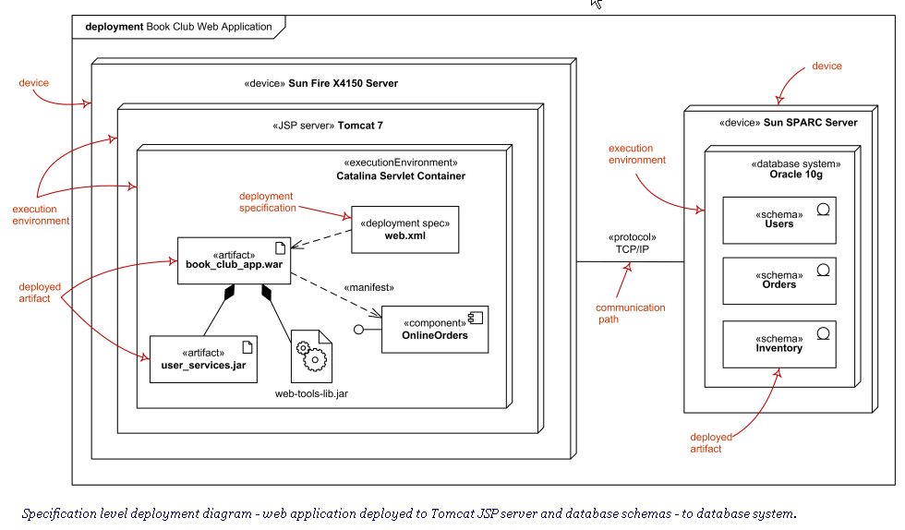

# ***Deployment Diagram for “Personal Counseling ”***

Following is the Deployment diagram for Personal Counseling.

## ***Deployment diagram***

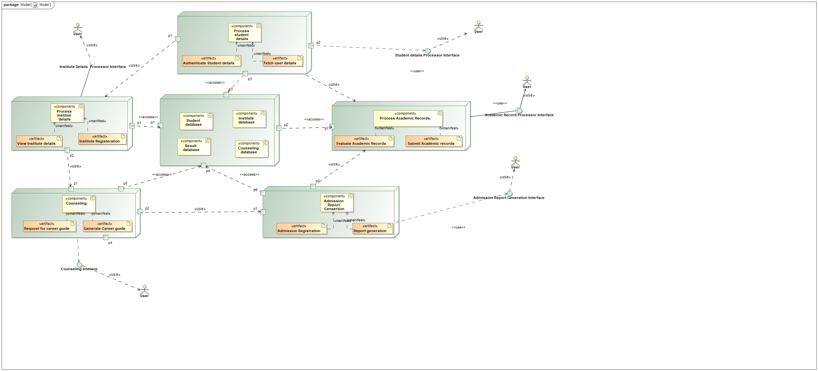

**1. Node Description: Process User Details.**

The main motive is to register a student in the system. The student details are stored in the database.The login web page is loaded on the screen.Registration form is searched for new student registration.The registration form will be displayed for creation of a user profile as a student if the user account is not already existing.Login page will be loaded if the student account already exists.Students enter basic information needed in the registration form.The data is validated and if the data is correct then the data will be saved in the database.If no username clashes with the entered username then registration is processed further.System Loads two form on the screen: Login and Sign Up.Login page is loaded if the student's account already exist.Student enters login username and password.Login records are fetched from the student database.The entered details are checked whether they are present in fetched login records.System access is provided to the student by logging him in the system.Users select Login after sign Up is completed.

**2. Node Description: Process Institute Details.**

The main motive is that the Institute record is to be maintained in the system. New institute details are to be entered in the system.Verified university details are recorded in the database.Login page will be loaded if the university details are already present in the system.Registration page is loaded in case university details are not present in the system.The data is validated and if the data is correct then the data will be saved in the database.University license is verified.Institute details are stored in the database.A message of successful university registration is displayed. If a student wants to see university details then the student enters login username and password.Login records are fetched from the student database.The entered details are checked whether they are present in fetched login records.Access to university details is given to the student.University updates any details if necessary and submit the registration form.

**3. Node Description: Process Academic Records.**

The main goal is that .System shall enable students to upload results so that institutes process academic records.Student opens the application.System fetches the database of the user.Current student information is displayed.Student uploads academic record. Changes are validated on the web server.A Confirmation webpage is sent to the user.Institutes evaluate multiple academic records.Academic records are fetched from the database.A merit list is published. User wants to delete a particular document.Database is updated in case new documents are added.System processes the information taken into the system.Changes in the database must be verified.Students acknowledge the success message of changes.

**4. Node Description: Counseling.**

The main goal is that students can request for career guidance.System provides login id.System fetches the academic records from the database.Advisor logs in the system.Student records are evaluated.Academic record is compared according to merit list.Advisor fetches relevant courses from the database.Student profile is matched accordingly.Career guide is generated.Guide report is then approved by the registered user.Student request for another suggestion if not approved. Alternate career options are fetched from the database.Revised report is sent to the student.

**5. Node Description:** Admission report generation

The System shall provide a final admission report for a student.Student examines the counselling report.Students apply to the institute.Student details are retrieved.Students select a course.Students pay the admission fee by entering bank details.System verifies the student details.Student profile is analysed by the institute.Verification is sent to the student.Students acknowledge the confirmation message.Student request for another suggestion if admission is not approved.Student details are further examined.Alternate institute options are fetched from the database.Students complete further application by applying to suggested institutes.

***Design Pattern***

***Assignment 10– SDP LAB (CS3036)***

***Personal Counselling System***

Department of Computer Engineering

**BRACT’S Vishwakarma Institute Technology**

***PUNE – 411 037***



*Prepared by:*

|  |  |  |  |
| --- | --- | --- | --- |
| **Name** | **Division** | **Roll Number** | **GR Number** |
| Riya Mate | T.Y. D | 8 | 1710954 |
| Neha Khare | T.Y. D | 18 | 1710176 |
| Aditi Patil | T.Y. D | 28 | 1710383 |
| Akshay Patil | T.Y. D | 29 | 1710456 |

*Approved by:*

|  |  |  |
| --- | --- | --- |
| ***Name*** | ***Signature*** | ***Date*** |
| *Prof. Mahesh Dube* |  | *30th Mar 2020* |

|  |
| --- |
| ***Design Pattern Diagram*** |

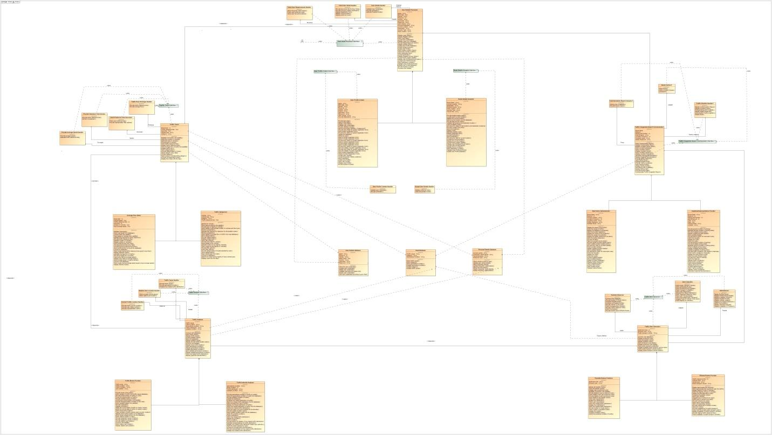

|  |
| --- |
| ***1.1 Design Pattern Description - Student Registration*** |

**Abstract Factory:**

Abstract factory is used in this goal because some functions are dependent on others such as sending Validate User Credentials. This operation depends upon the credentials entered by the user. Estimation of possible interests is dependent upon academic record fetched. Display of notification is also dependent upon the validation of results.

**Façade:**

In this goal there are some higher level interfaces that make other subsystems easier to use such as providing dropdown list for institute and field options. The system will also be displaying a notification to the user about the successful login process.

**Structure:**

Structure is used to store the previous academic records of the user and also store the user preferred institute and field into the user database. It is used to store the favorite institute and field of the user which he/she has entered into the personalized registration form.

|  |
| --- |
| ***1.2 Design Pattern Description - Institute Registration*** |

**Abstract Factory:**

Abstract factory is used in this goal because some functions are dependent on others such as sending Validate User Credentials. This operation depends upon the credentials entered by the user. Estimation of seats available is dependent upon previous year records fetched. Display of notification is also dependent upon the validation of results.

**Façade:**

In this goal there are some higher level interfaces that make other subsystems easier to use such as providing dropdown list for institute and field options. The system will also be displaying a notification to the user about the successful login process.

**Structure:**

Structure is used to store the previous year admission records of the institute and also store the available fields and seats in the institute into the institute database. It is used to store the cut-offs and merits of all fields of institute which admin has entered into the registration form.

|  |
| --- |
| ***1.3 Design Pattern Description - Add Academic Record*** |

**Bridge:**

Bridge decouple an abstraction from its implementation so that the two can vary independently. Here methods like accessing, sharing, modifying student academic records differ from creating a student profile, and hence a bridge is provided.

**Template:**

Templates define the skeleton of an algorithm in an operation, deferring some steps to subclasses. Template Method lets subclasses redefine certain steps of an algorithm without changing the algorithm's structure. Here we have a form template to fill a student’s academic details to create his record. Hence template patterns are used.

**Abstract Factory:**

Abstract factory is used in this goal because some functions are dependent on others such as sending Validate academic details. This operation depends upon the details entered by the user. Display of notification is also dependent upon the validation of results.

|  |
| --- |
| ***1.4 Design Pattern Description - Provide Counselling*** |

**Builder:**

Builder design pattern is used to fetch academic records of the user. Previous academic records of the user will be provided by the system with the help of the data provided by the educational authorities. Builder is also used to fetch approximate interests.

**Observer:**

The observer design pattern is used to display or provide the institute's current performance as well as to display field based performance based upon the selected choice of the user.

**Bridge:**

Bridge design pattern is used to fetch the institute details. The institute details are fetched from the database and the data is later analyzed to provide the user with the most suitable seat and user’s past performance.

|  |
| --- |
| ***1.5 Design Pattern Description - Generate Report*** |

**Proxy:**

Proxy design pattern is used to describe the availability of the seats in Government institutes as well as a search option for available seats in Private institutes.

**Adapter:**

Adapter design pattern is used to fetch the academic record details of students and the available seats in different fields according to categories in institutes.

**Factory Method:**

Factory method is used to provide the students with the final details of the student preferred field and institute and the most suitable seat.

# ***Screenshots of “Personal Counseling System “***

